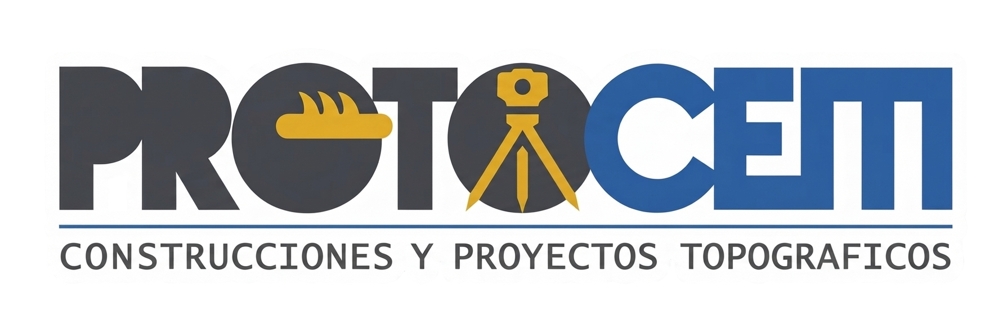
CORPORATE DOSSIER
PROTOCEM – TOPOGRAPHIC & CONSTRUCTION PROJECTS
Aguascalientes, Mexico
RFC: MACC840025F92
protocem@hotmail.com | +52 449-137-29-71

CORPORATE PROFILE
PROTOCEM is a Mexican company specialized in civil, industrial, urban, hydraulic and energy infrastructure projects. The company has extensive experience in public and private sector construction, executing large-scale developments with high standards of quality, operational efficiency and technical compliance.
CORE SERVICES
- Industrial building construction and expansion
- Hydraulic and sanitary infrastructure
- Urbanization and paving works
- Earthworks and road infrastructure
- Wastewater treatment plants
- Steel structures and roofing systems
- Educational and medical infrastructure
- Electrical, voice and data systems
- Commercial and residential construction
- Construction consulting and supervision

EXECUTED PROJECTS
PROJECT 1
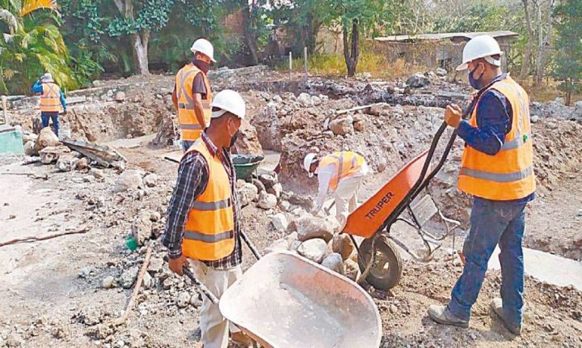
Large-scale infrastructure and construction project executed by PROTOCEM, including civil works, urban development, industrial facilities, hydraulic systems, paving, electrical installations and specialized construction services.
PROJECT 2
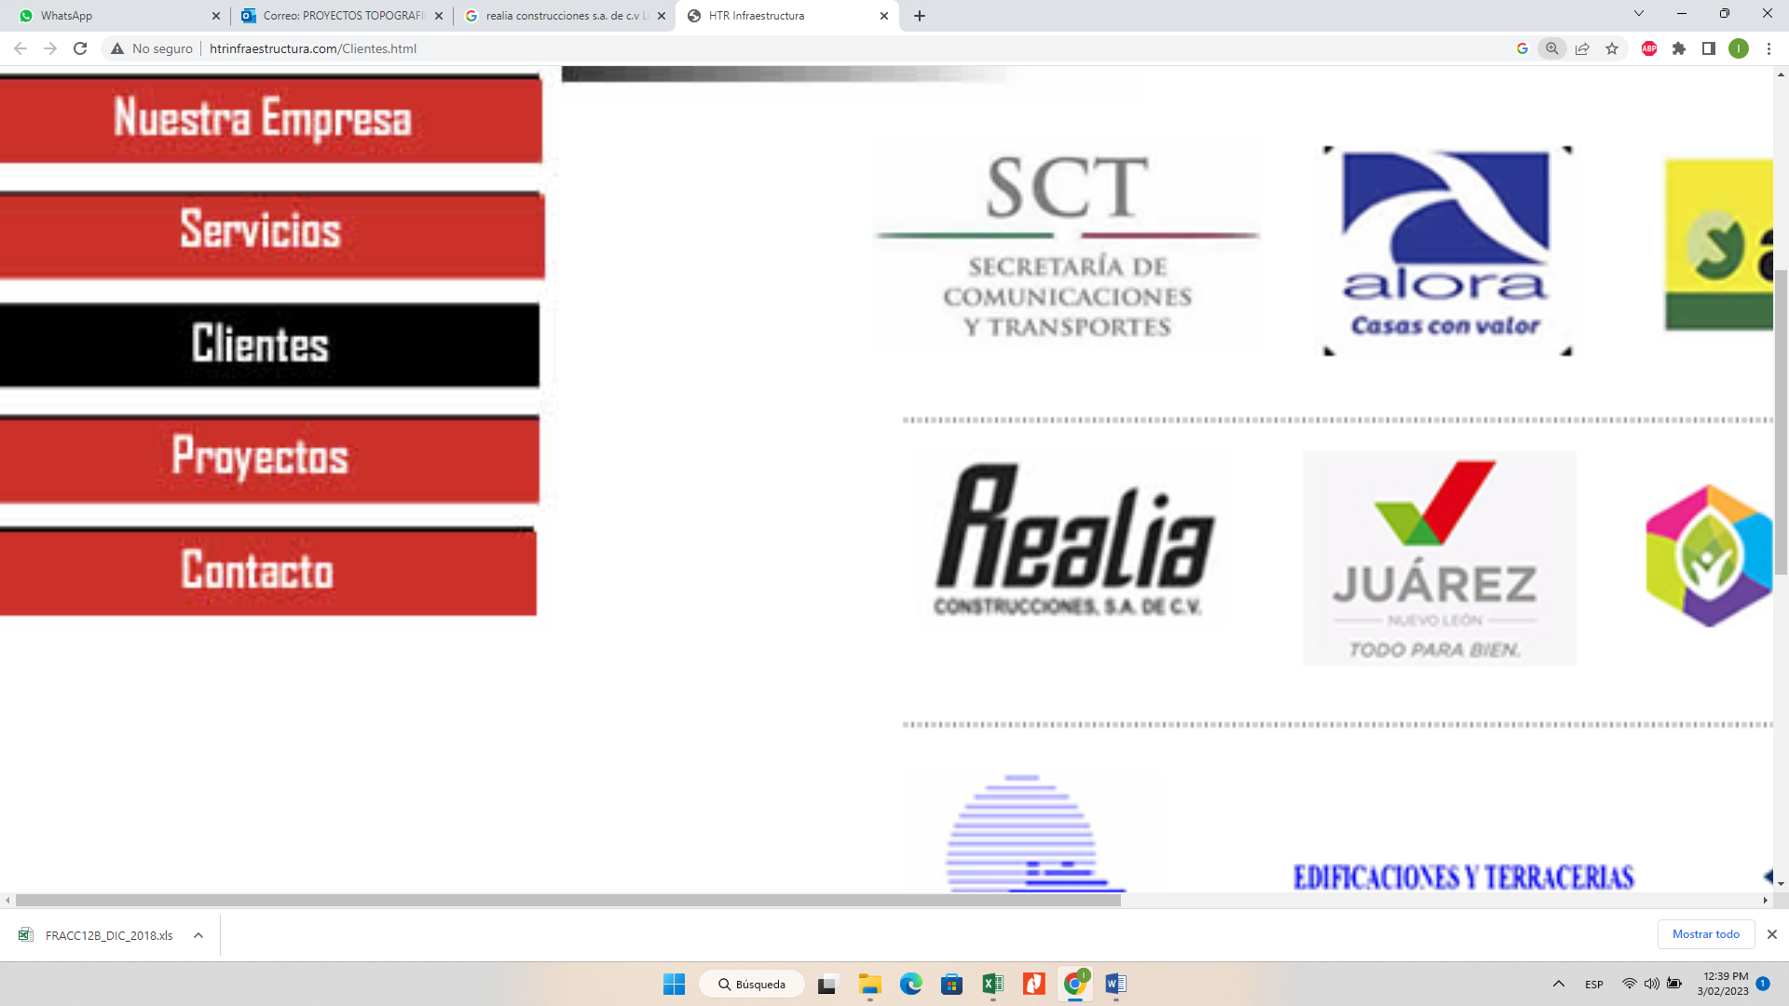
Large-scale infrastructure and construction project executed by PROTOCEM, including civil works, urban development, industrial facilities, hydraulic systems, paving, electrical installations and specialized construction services.
PROJECT 3
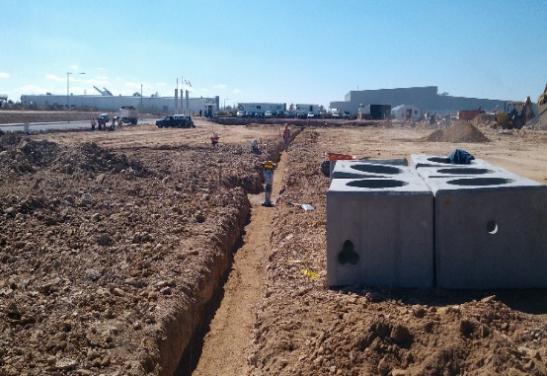
Large-scale infrastructure and construction project executed by PROTOCEM, including civil works, urban development, industrial facilities, hydraulic systems, paving, electrical installations and specialized construction services.
PROJECT 4
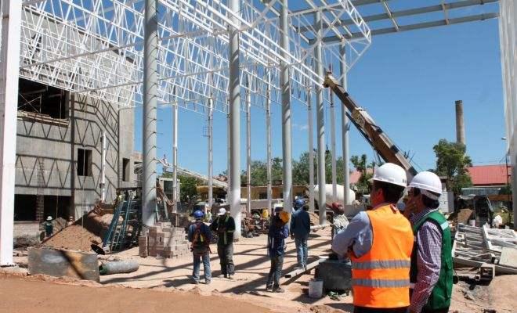
Large-scale infrastructure and construction project executed by PROTOCEM, including civil works, urban development, industrial facilities, hydraulic systems, paving, electrical installations and specialized construction services.
PROJECT 5
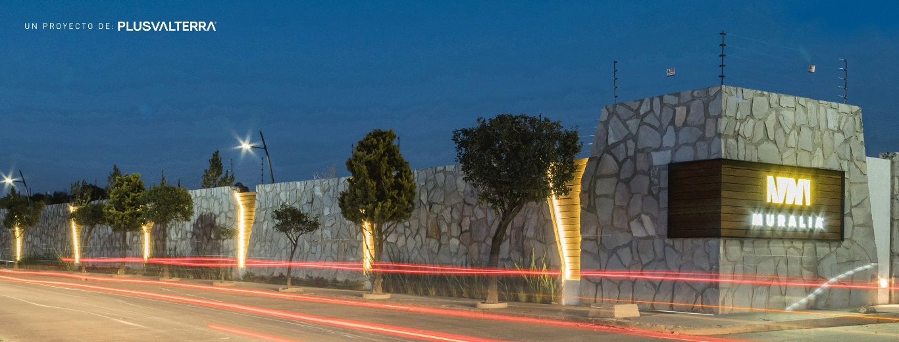
Large-scale infrastructure and construction project executed by PROTOCEM, including civil works, urban development, industrial facilities, hydraulic systems, paving, electrical installations and specialized construction services.
PROJECT 6
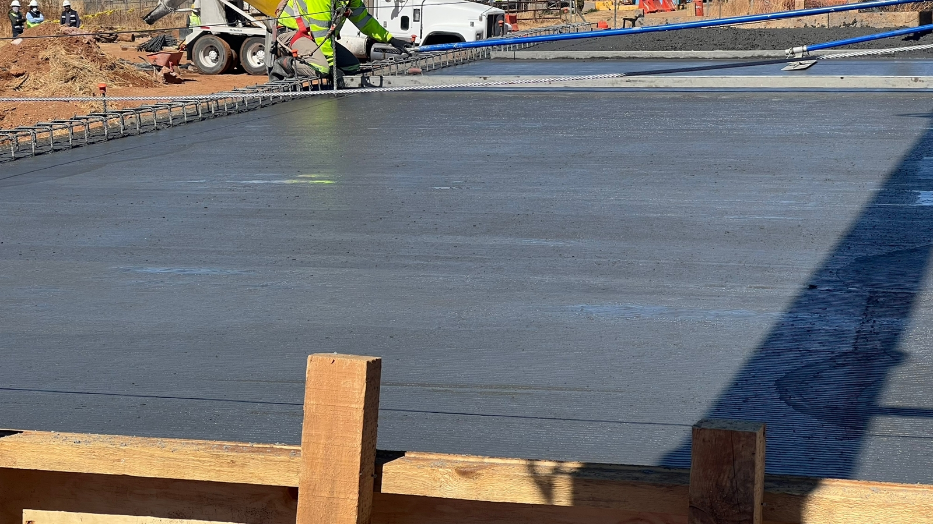
Large-scale infrastructure and construction project executed by PROTOCEM, including civil works, urban development, industrial facilities, hydraulic systems, paving, electrical installations and specialized construction services.
PROJECT 7
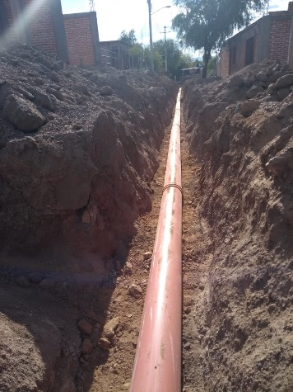
Large-scale infrastructure and construction project executed by PROTOCEM, including civil works, urban development, industrial facilities, hydraulic systems, paving, electrical installations and specialized construction services.
PROJECT 8

Large-scale infrastructure and construction project executed by PROTOCEM, including civil works, urban development, industrial facilities, hydraulic systems, paving, electrical installations and specialized construction services.
PROJECT 9
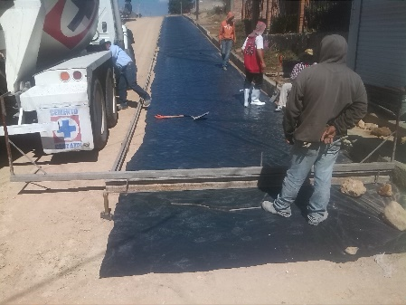
Large-scale infrastructure and construction project executed by PROTOCEM, including civil works, urban development, industrial facilities, hydraulic systems, paving, electrical installations and specialized construction services.
PROJECT 10
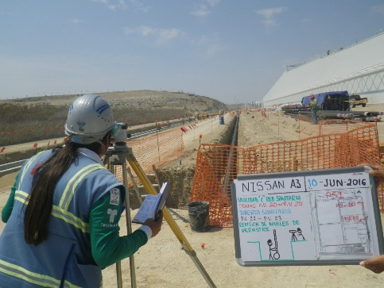
Large-scale infrastructure and construction project executed by PROTOCEM, including civil works, urban development, industrial facilities, hydraulic systems, paving, electrical installations and specialized construction services.
PROJECT 11
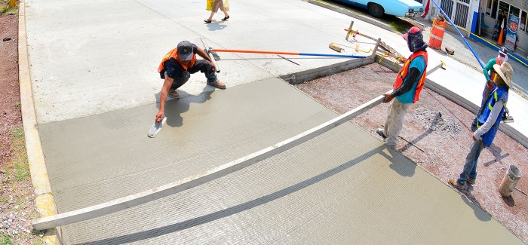
Large-scale infrastructure and construction project executed by PROTOCEM, including civil works, urban development, industrial facilities, hydraulic systems, paving, electrical installations and specialized construction services.
PROJECT 12
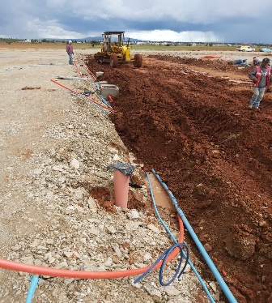
Large-scale infrastructure and construction project executed by PROTOCEM, including civil works, urban development, industrial facilities, hydraulic systems, paving, electrical installations and specialized construction services.
PROJECT 13
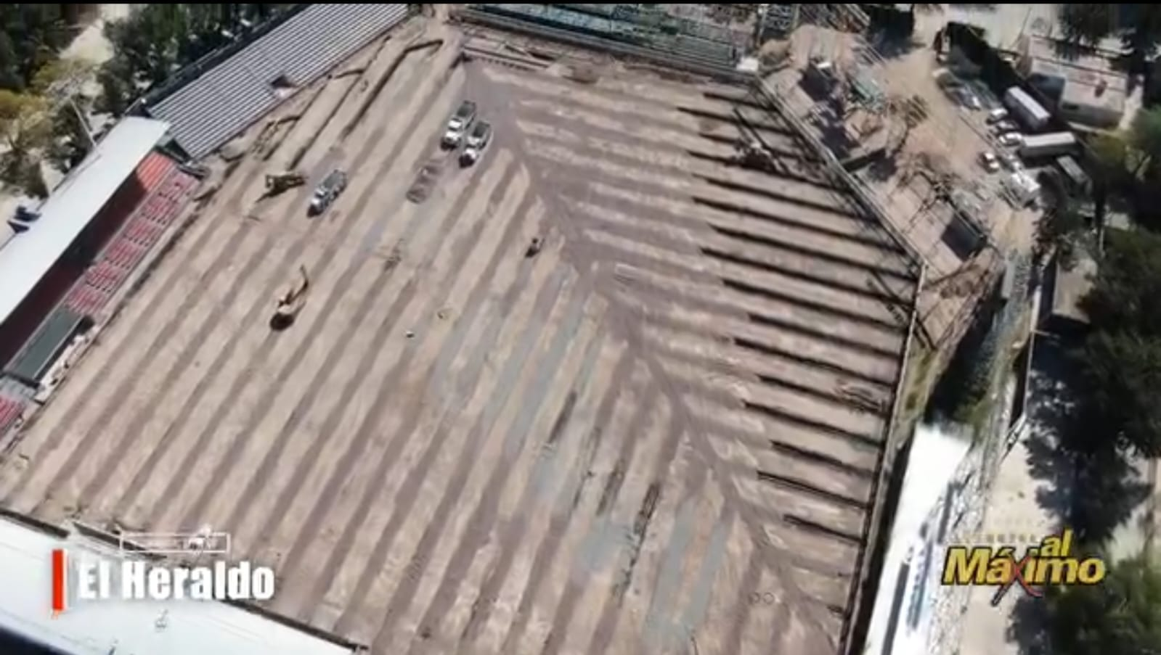
Large-scale infrastructure and construction project executed by PROTOCEM, including civil works, urban development, industrial facilities, hydraulic systems, paving, electrical installations and specialized construction services.
PROJECT 14
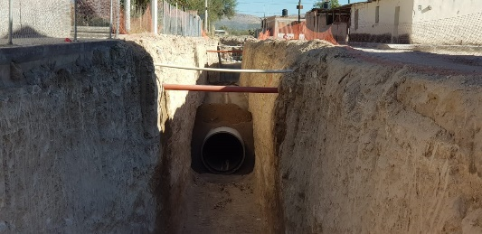
Large-scale infrastructure and construction project executed by PROTOCEM, including civil works, urban development, industrial facilities, hydraulic systems, paving, electrical installations and specialized construction services.
PROJECT 15

Large-scale infrastructure and construction project executed by PROTOCEM, including civil works, urban development, industrial facilities, hydraulic systems, paving, electrical installations and specialized construction services.
PROJECT 16
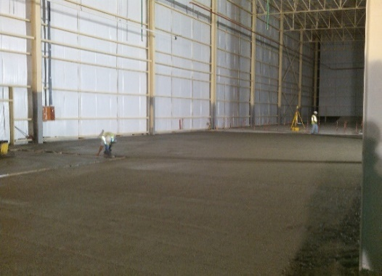
Large-scale infrastructure and construction project executed by PROTOCEM, including civil works, urban development, industrial facilities, hydraulic systems, paving, electrical installations and specialized construction services.
PROJECT 17
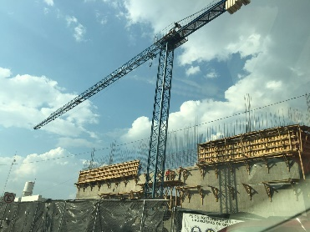
Large-scale infrastructure and construction project executed by PROTOCEM, including civil works, urban development, industrial facilities, hydraulic systems, paving, electrical installations and specialized construction services.
PROJECT 18
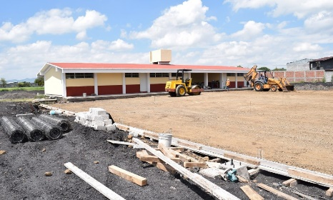
Large-scale infrastructure and construction project executed by PROTOCEM, including civil works, urban development, industrial facilities, hydraulic systems, paving, electrical installations and specialized construction services.
PROJECT 19
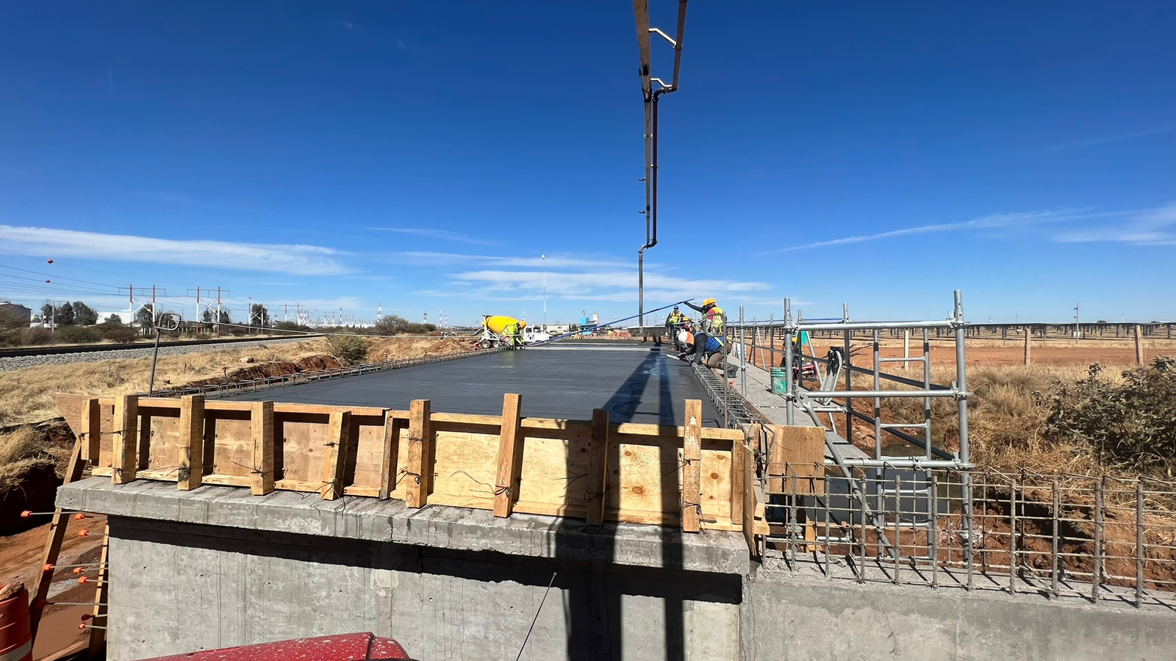
Large-scale infrastructure and construction project executed by PROTOCEM, including civil works, urban development, industrial facilities, hydraulic systems, paving, electrical installations and specialized construction services.
PROJECT 20
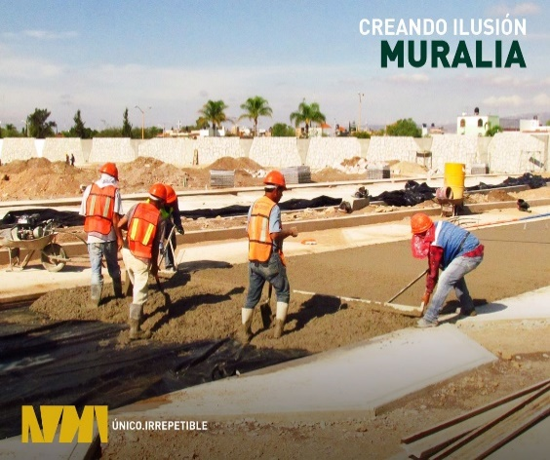
Large-scale infrastructure and construction project executed by PROTOCEM, including civil works, urban development, industrial facilities, hydraulic systems, paving, electrical installations and specialized construction services.
PROJECT 21
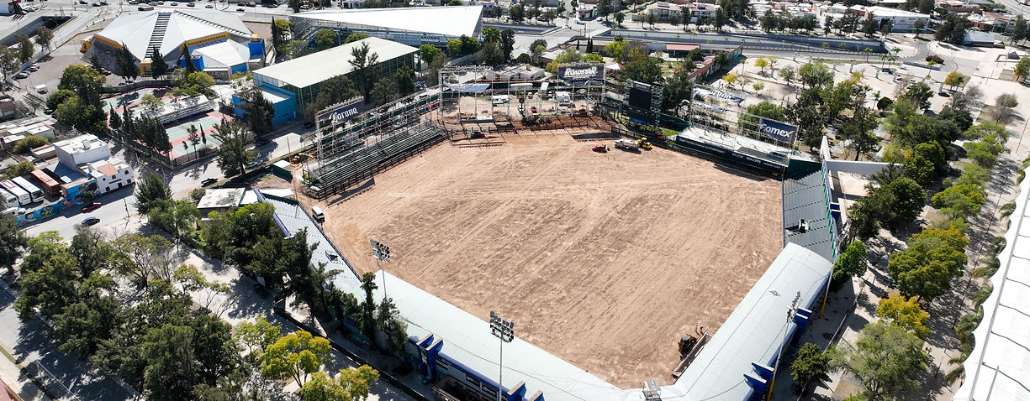
Large-scale infrastructure and construction project executed by PROTOCEM, including civil works, urban development, industrial facilities, hydraulic systems, paving, electrical installations and specialized construction services.
PROJECT 22
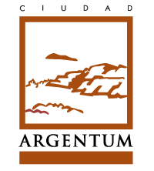
Large-scale infrastructure and construction project executed by PROTOCEM, including civil works, urban development, industrial facilities, hydraulic systems, paving, electrical installations and specialized construction services.
PROJECT 23
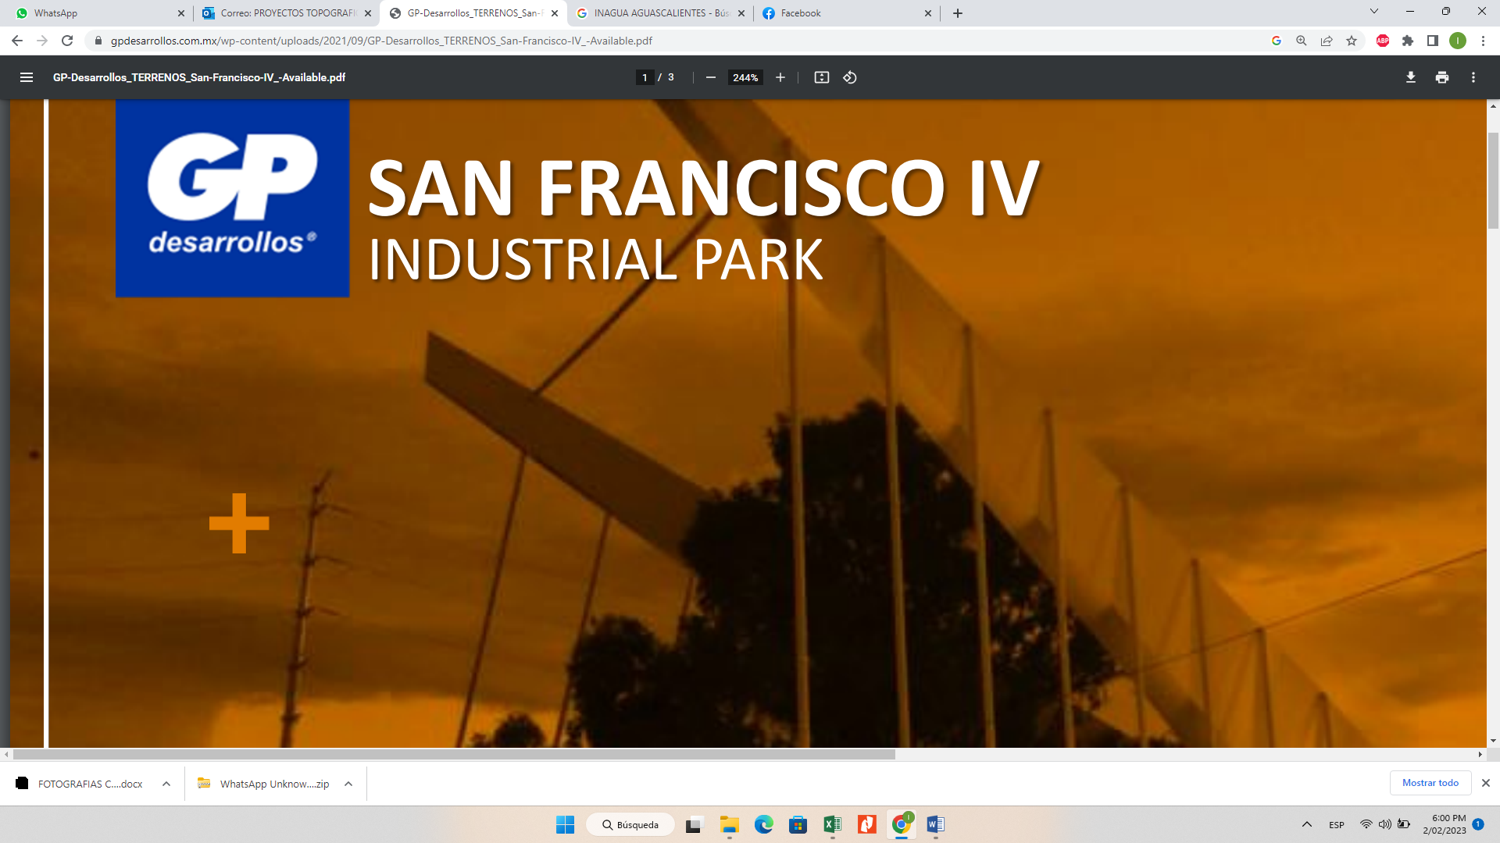
Large-scale infrastructure and construction project executed by PROTOCEM, including civil works, urban development, industrial facilities, hydraulic systems, paving, electrical installations and specialized construction services.
PROJECT 24
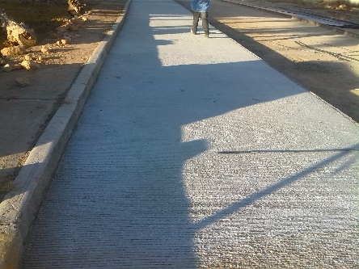
Large-scale infrastructure and construction project executed by PROTOCEM, including civil works, urban development, industrial facilities, hydraulic systems, paving, electrical installations and specialized construction services.
PROJECT 25
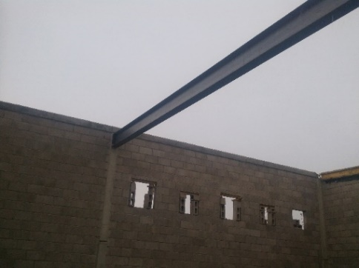
Large-scale infrastructure and construction project executed by PROTOCEM, including civil works, urban development, industrial facilities, hydraulic systems, paving, electrical installations and specialized construction services.
PROJECT 26
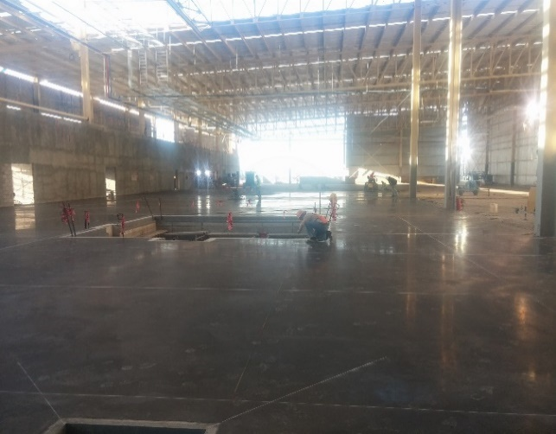
Large-scale infrastructure and construction project executed by PROTOCEM, including civil works, urban development, industrial facilities, hydraulic systems, paving, electrical installations and specialized construction services.
PROJECT 27
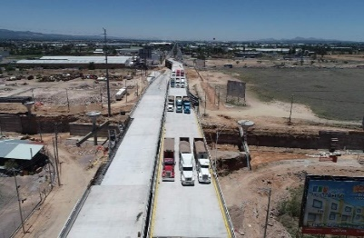
Large-scale infrastructure and construction project executed by PROTOCEM, including civil works, urban development, industrial facilities, hydraulic systems, paving, electrical installations and specialized construction services.
PROJECT 28
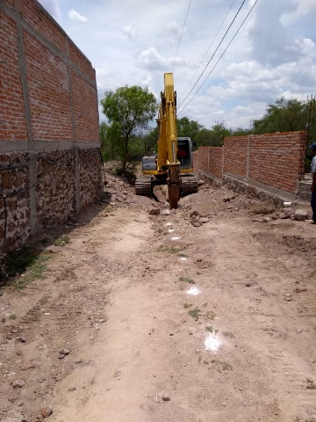
Large-scale infrastructure and construction project executed by PROTOCEM, including civil works, urban development, industrial facilities, hydraulic systems, paving, electrical installations and specialized construction services.
PROJECT 29
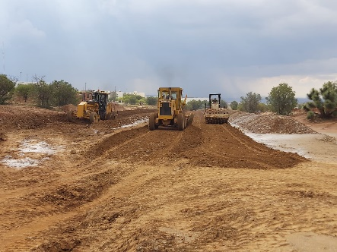
Large-scale infrastructure and construction project executed by PROTOCEM, including civil works, urban development, industrial facilities, hydraulic systems, paving, electrical installations and specialized construction services.
PROJECT 30
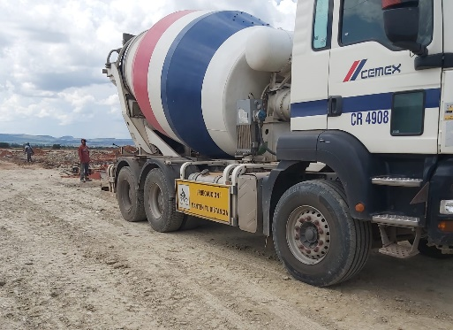
Large-scale infrastructure and construction project executed by PROTOCEM, including civil works, urban development, industrial facilities, hydraulic systems, paving, electrical installations and specialized construction services.
PROJECT 31
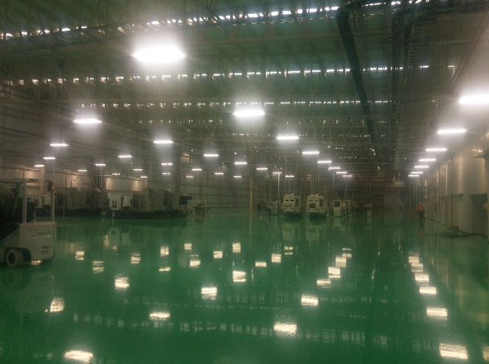
Large-scale infrastructure and construction project executed by PROTOCEM, including civil works, urban development, industrial facilities, hydraulic systems, paving, electrical installations and specialized construction services.
PROJECT 32
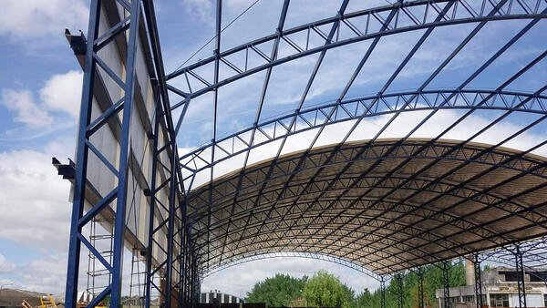
Large-scale infrastructure and construction project executed by PROTOCEM, including civil works, urban development, industrial facilities, hydraulic systems, paving, electrical installations and specialized construction services.
PROJECT 33
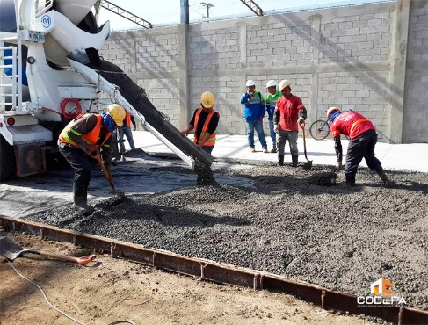
Large-scale infrastructure and construction project executed by PROTOCEM, including civil works, urban development, industrial facilities, hydraulic systems, paving, electrical installations and specialized construction services.
PROJECT 34
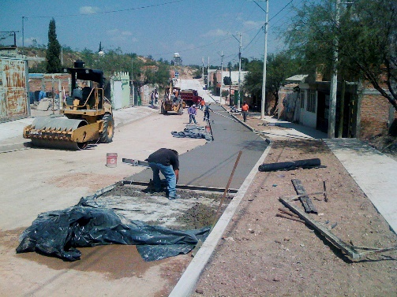
Large-scale infrastructure and construction project executed by PROTOCEM, including civil works, urban development, industrial facilities, hydraulic systems, paving, electrical installations and specialized construction services.
PROJECT 35
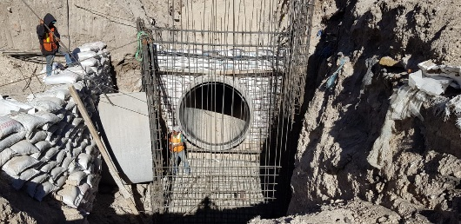
Large-scale infrastructure and construction project executed by PROTOCEM, including civil works, urban development, industrial facilities, hydraulic systems, paving, electrical installations and specialized construction services.
PROJECT 36
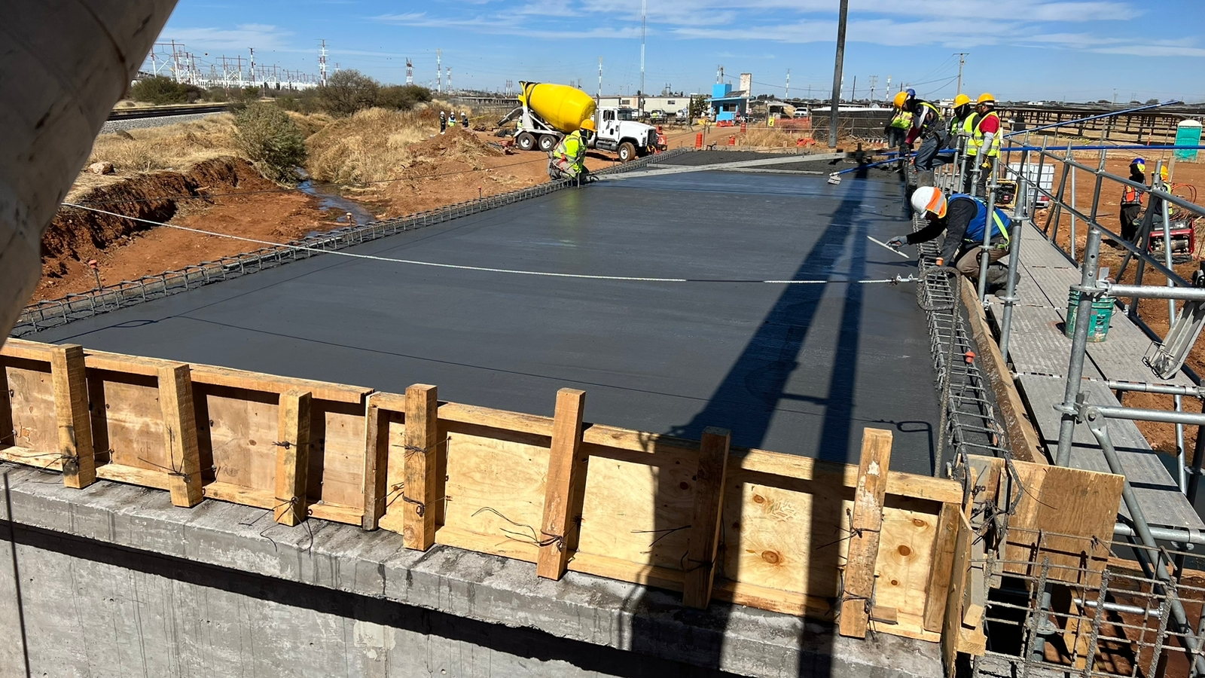
Large-scale infrastructure and construction project executed by PROTOCEM, including civil works, urban development, industrial facilities, hydraulic systems, paving, electrical installations and specialized construction services.
PROJECT 37
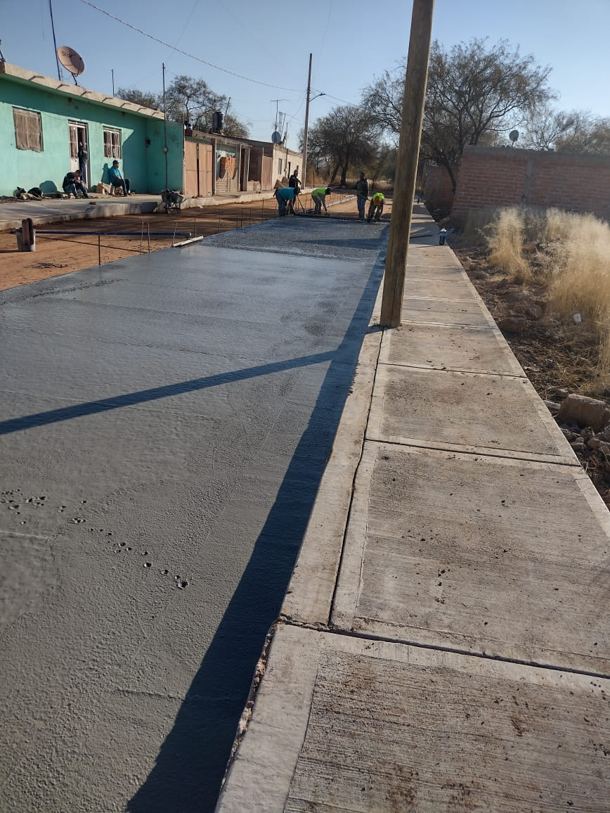
Large-scale infrastructure and construction project executed by PROTOCEM, including civil works, urban development, industrial facilities, hydraulic systems, paving, electrical installations and specialized construction services.
PROJECT 38
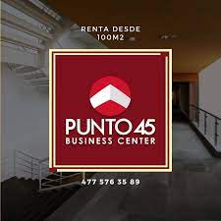
Large-scale infrastructure and construction project executed by PROTOCEM, including civil works, urban development, industrial facilities, hydraulic systems, paving, electrical installations and specialized construction services.
PROJECT 39
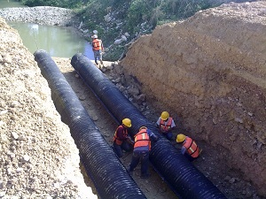
Large-scale infrastructure and construction project executed by PROTOCEM, including civil works, urban development, industrial facilities, hydraulic systems, paving, electrical installations and specialized construction services.
PROJECT 40
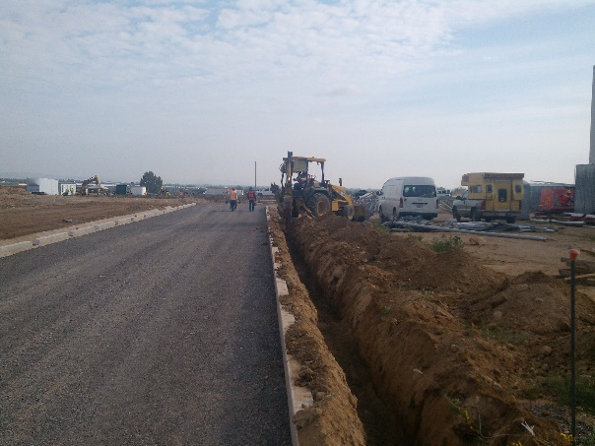
Large-scale infrastructure and construction project executed by PROTOCEM, including civil works, urban development, industrial facilities, hydraulic systems, paving, electrical installations and specialized construction services.
PROJECT 41
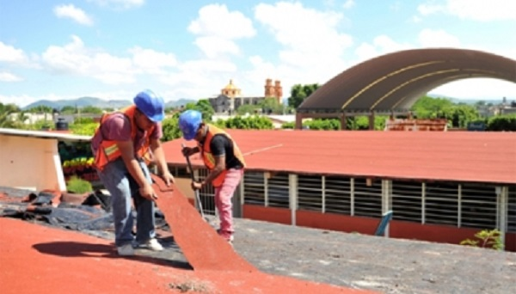
Large-scale infrastructure and construction project executed by PROTOCEM, including civil works, urban development, industrial facilities, hydraulic systems, paving, electrical installations and specialized construction services.
PROJECT 42
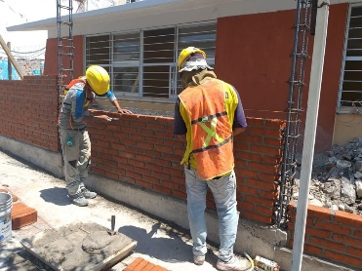
Large-scale infrastructure and construction project executed by PROTOCEM, including civil works, urban development, industrial facilities, hydraulic systems, paving, electrical installations and specialized construction services.
PROJECT 43
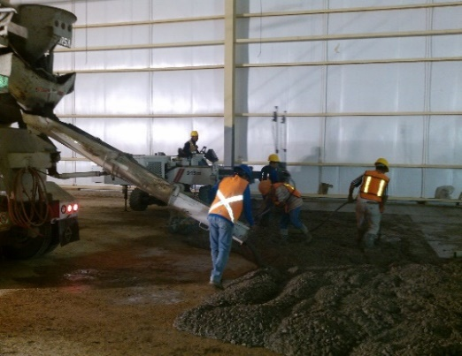
Large-scale infrastructure and construction project executed by PROTOCEM, including civil works, urban development, industrial facilities, hydraulic systems, paving, electrical installations and specialized construction services.
PROJECT 44
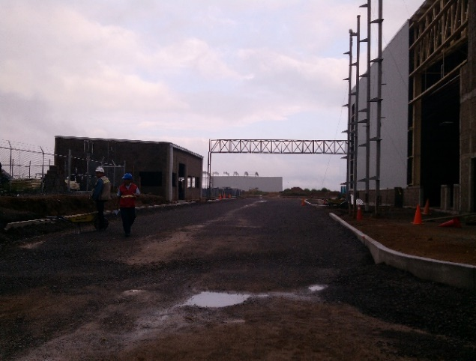
Large-scale infrastructure and construction project executed by PROTOCEM, including civil works, urban development, industrial facilities, hydraulic systems, paving, electrical installations and specialized construction services.
PROJECT 45
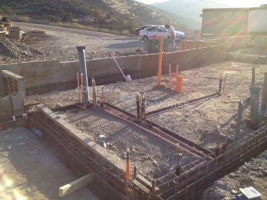
Large-scale infrastructure and construction project executed by PROTOCEM, including civil works, urban development, industrial facilities, hydraulic systems, paving, electrical installations and specialized construction services.
PROJECT 46
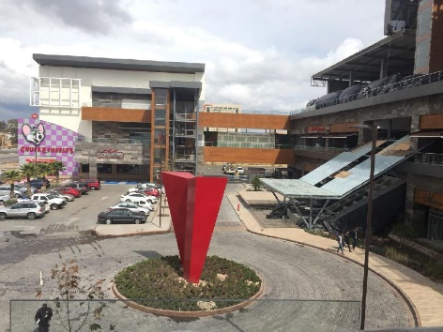
Large-scale infrastructure and construction project executed by PROTOCEM, including civil works, urban development, industrial facilities, hydraulic systems, paving, electrical installations and specialized construction services.
PROJECT 47
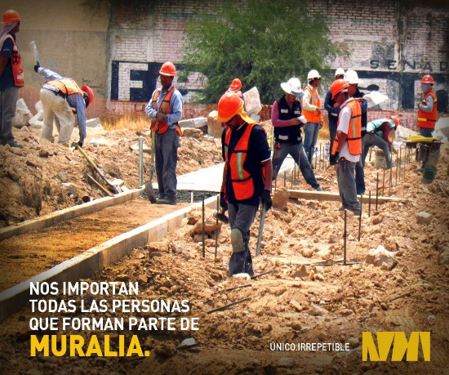
Large-scale infrastructure and construction project executed by PROTOCEM, including civil works, urban development, industrial facilities, hydraulic systems, paving, electrical installations and specialized construction services.
PROJECT 48
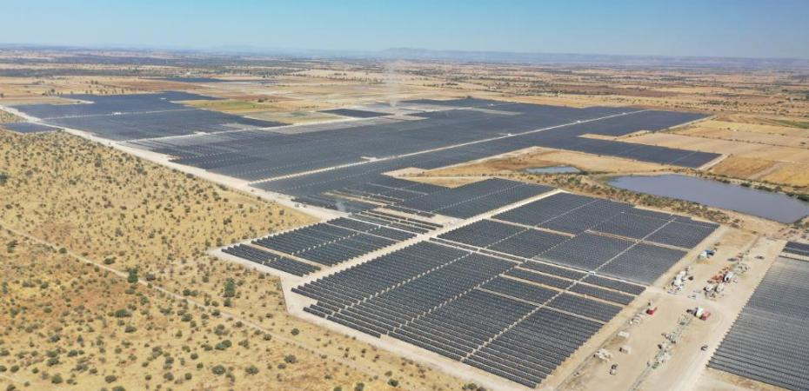
Large-scale infrastructure and construction project executed by PROTOCEM, including civil works, urban development, industrial facilities, hydraulic systems, paving, electrical installations and specialized construction services.
PROJECT 49
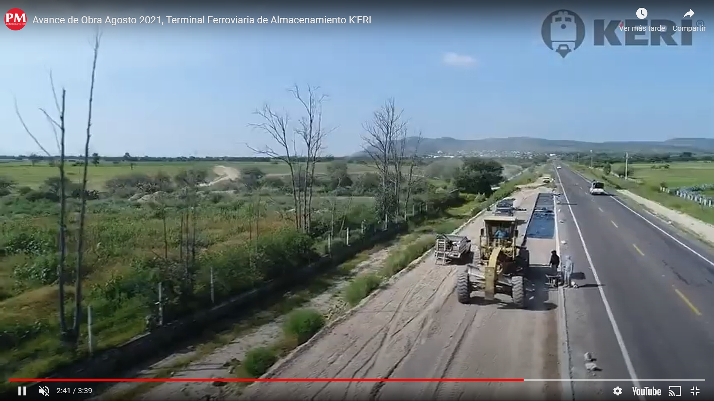
Large-scale infrastructure and construction project executed by PROTOCEM, including civil works, urban development, industrial facilities, hydraulic systems, paving, electrical installations and specialized construction services.
PROJECT 50
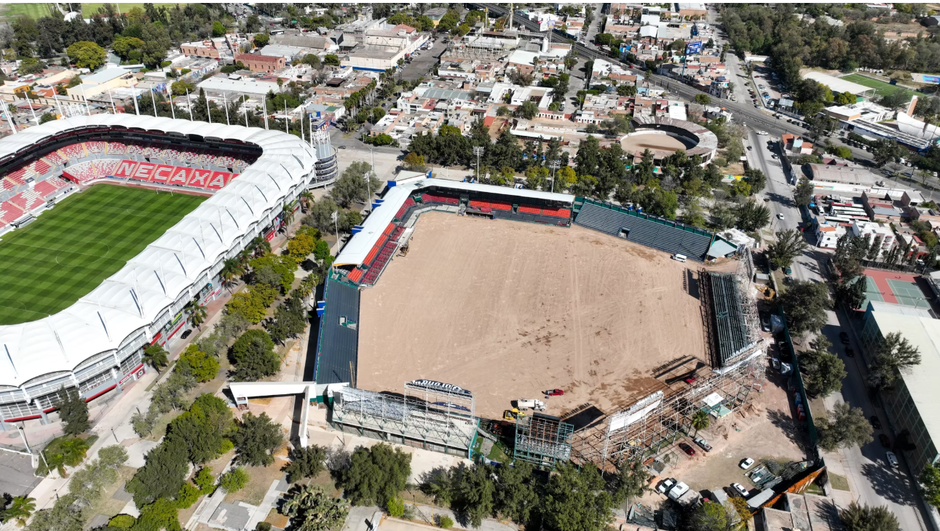
Large-scale infrastructure and construction project executed by PROTOCEM, including civil works, urban development, industrial facilities, hydraulic systems, paving, electrical installations and specialized construction services.
PROJECT 51
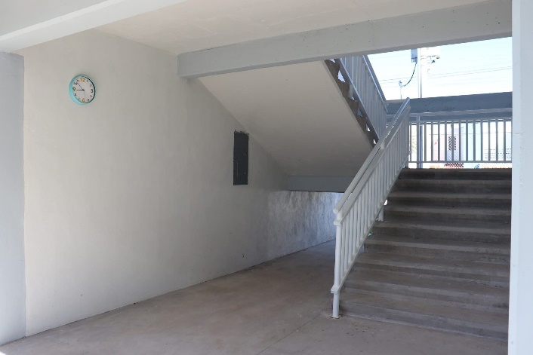
Large-scale infrastructure and construction project executed by PROTOCEM, including civil works, urban development, industrial facilities, hydraulic systems, paving, electrical installations and specialized construction services.
PROJECT 52

Large-scale infrastructure and construction project executed by PROTOCEM, including civil works, urban development, industrial facilities, hydraulic systems, paving, electrical installations and specialized construction services.
PROJECT 53

Large-scale infrastructure and construction project executed by PROTOCEM, including civil works, urban development, industrial facilities, hydraulic systems, paving, electrical installations and specialized construction services.
PROJECT 54
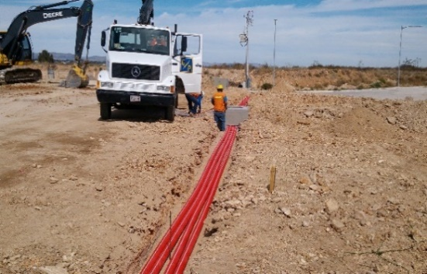
Large-scale infrastructure and construction project executed by PROTOCEM, including civil works, urban development, industrial facilities, hydraulic systems, paving, electrical installations and specialized construction services.
PROJECT 55
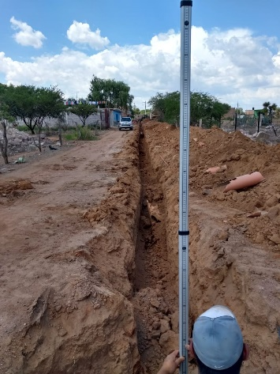
Large-scale infrastructure and construction project executed by PROTOCEM, including civil works, urban development, industrial facilities, hydraulic systems, paving, electrical installations and specialized construction services.
PROJECT 56
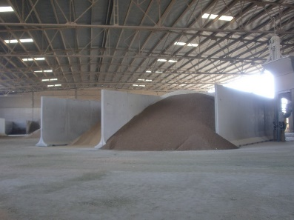
Large-scale infrastructure and construction project executed by PROTOCEM, including civil works, urban development, industrial facilities, hydraulic systems, paving, electrical installations and specialized construction services.
PROJECT 57
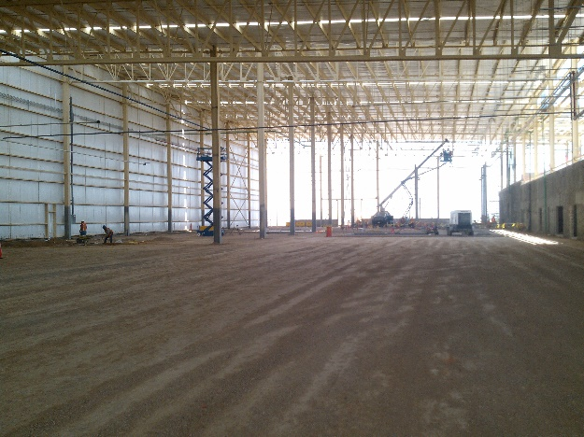
Large-scale infrastructure and construction project executed by PROTOCEM, including civil works, urban development, industrial facilities, hydraulic systems, paving, electrical installations and specialized construction services.
PROJECT 58
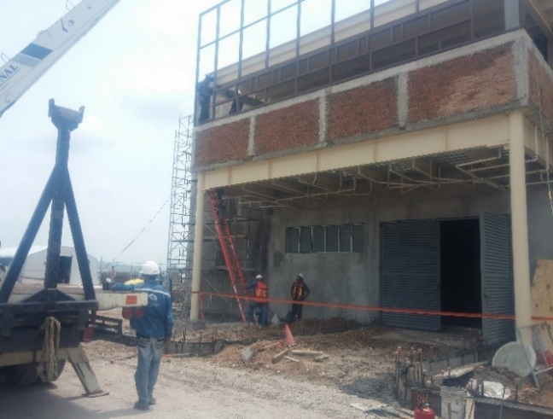
Large-scale infrastructure and construction project executed by PROTOCEM, including civil works, urban development, industrial facilities, hydraulic systems, paving, electrical installations and specialized construction services.
PROJECT 59
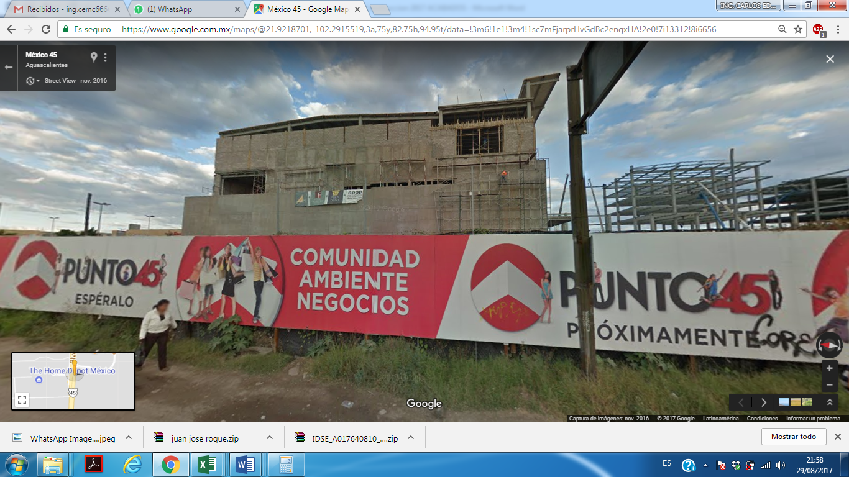
Large-scale infrastructure and construction project executed by PROTOCEM, including civil works, urban development, industrial facilities, hydraulic systems, paving, electrical installations and specialized construction services.
PROJECT 60
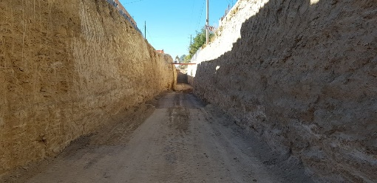
Large-scale infrastructure and construction project executed by PROTOCEM, including civil works, urban development, industrial facilities, hydraulic systems, paving, electrical installations and specialized construction services.
PROJECT 61
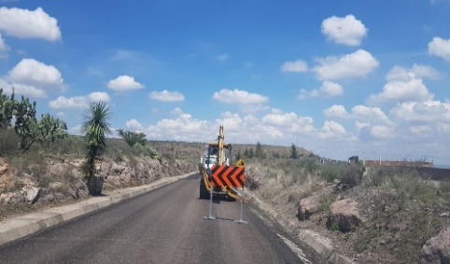
Large-scale infrastructure and construction project executed by PROTOCEM, including civil works, urban development, industrial facilities, hydraulic systems, paving, electrical installations and specialized construction services.
PROJECT 62
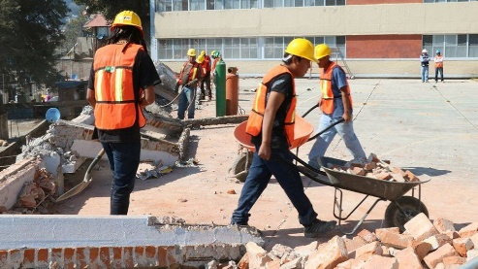
Large-scale infrastructure and construction project executed by PROTOCEM, including civil works, urban development, industrial facilities, hydraulic systems, paving, electrical installations and specialized construction services.
PROJECT 63
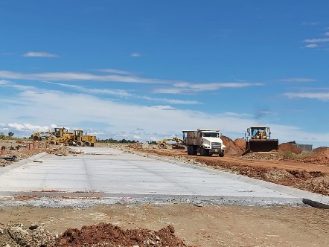
Large-scale infrastructure and construction project executed by PROTOCEM, including civil works, urban development, industrial facilities, hydraulic systems, paving, electrical installations and specialized construction services.
PROJECT 64
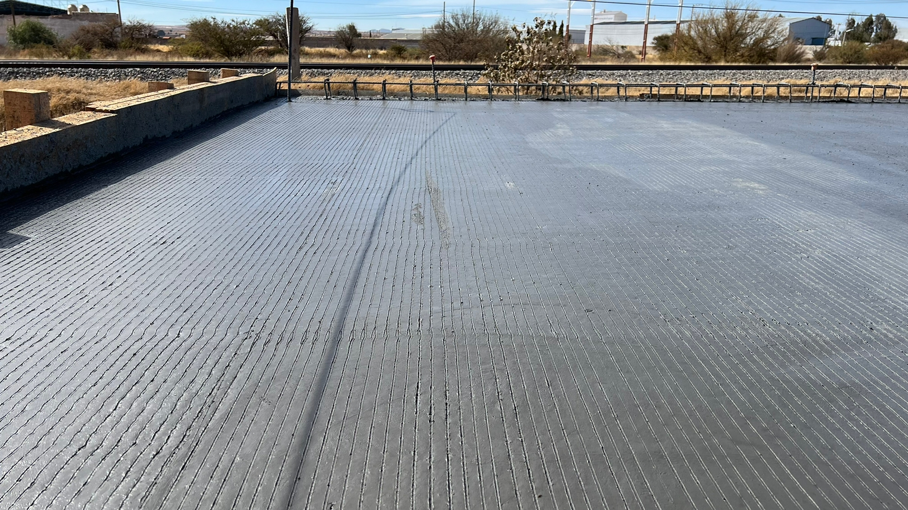
Large-scale infrastructure and construction project executed by PROTOCEM, including civil works, urban development, industrial facilities, hydraulic systems, paving, electrical installations and specialized construction services.
PROJECT 65
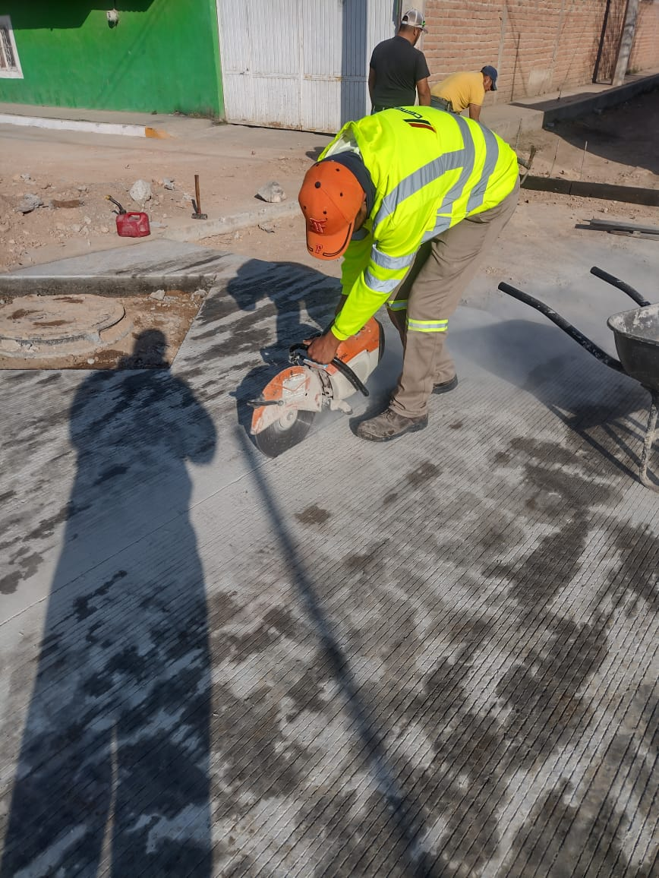
Large-scale infrastructure and construction project executed by PROTOCEM, including civil works, urban development, industrial facilities, hydraulic systems, paving, electrical installations and specialized construction services.
PROJECT 66
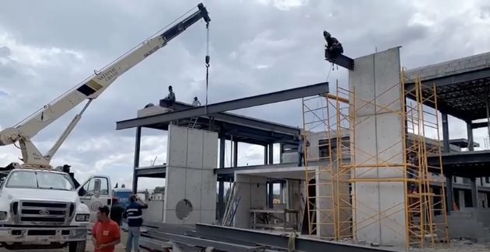
Large-scale infrastructure and construction project executed by PROTOCEM, including civil works, urban development, industrial facilities, hydraulic systems, paving, electrical installations and specialized construction services.
PROJECT 67
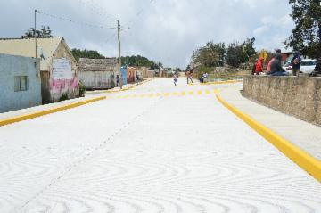
Large-scale infrastructure and construction project executed by PROTOCEM, including civil works, urban development, industrial facilities, hydraulic systems, paving, electrical installations and specialized construction services.
PROJECT 68
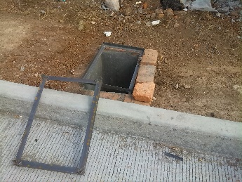
Large-scale infrastructure and construction project executed by PROTOCEM, including civil works, urban development, industrial facilities, hydraulic systems, paving, electrical installations and specialized construction services.
PROJECT 69
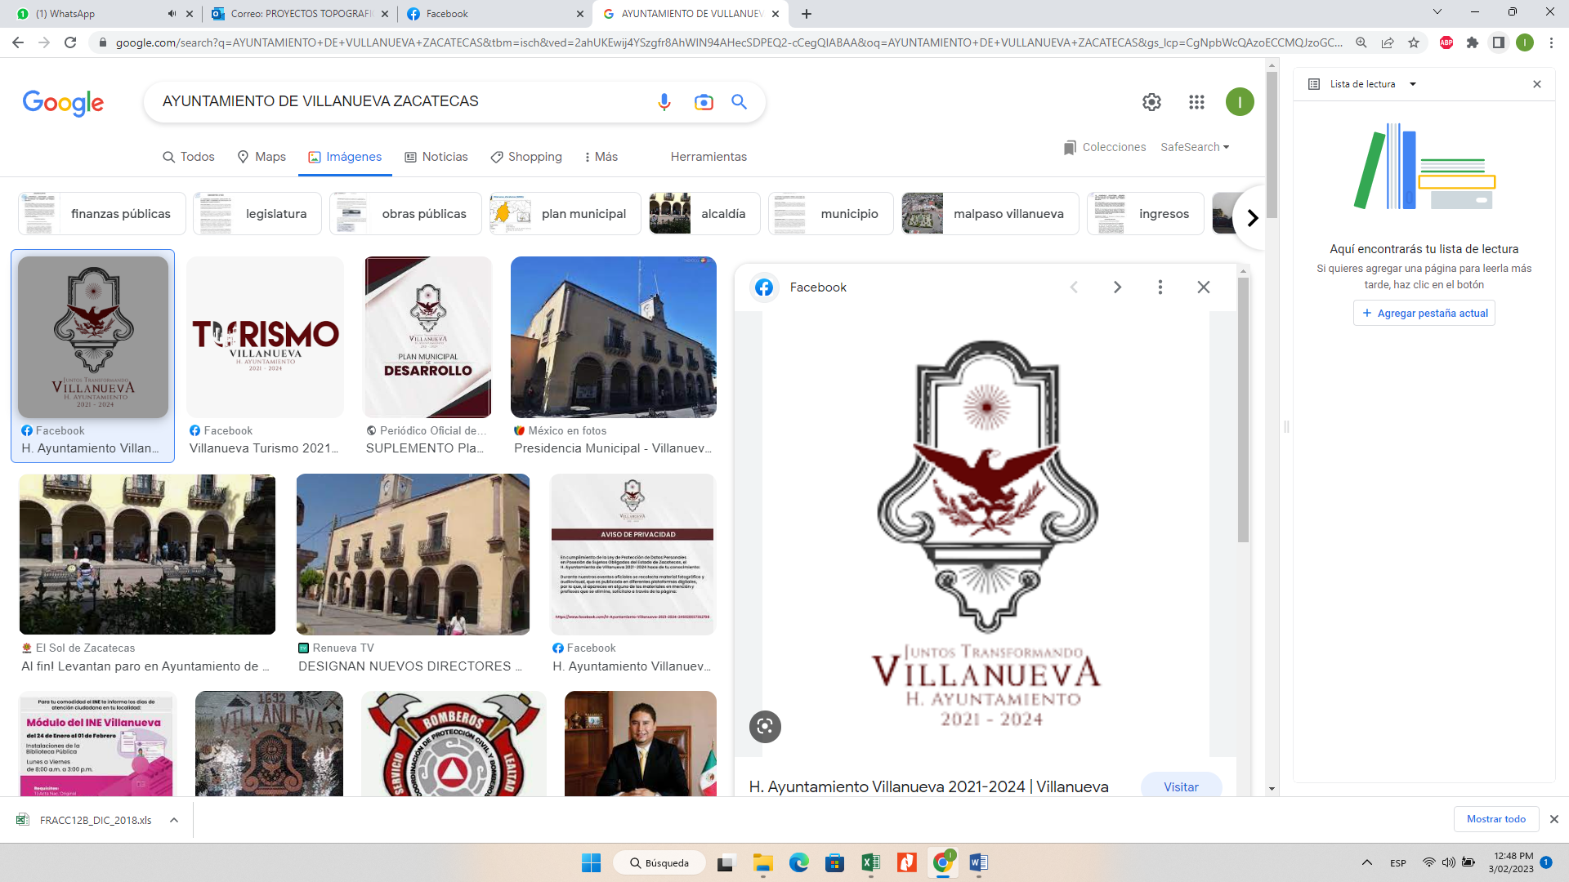
Large-scale infrastructure and construction project executed by PROTOCEM, including civil works, urban development, industrial facilities, hydraulic systems, paving, electrical installations and specialized construction services.
PROJECT 70
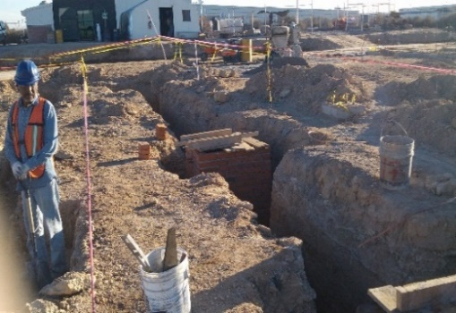
Large-scale infrastructure and construction project executed by PROTOCEM, including civil works, urban development, industrial facilities, hydraulic systems, paving, electrical installations and specialized construction services.
PROJECT 71
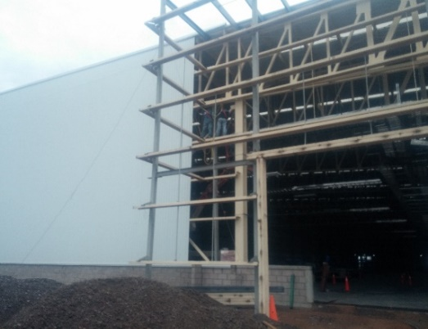
Large-scale infrastructure and construction project executed by PROTOCEM, including civil works, urban development, industrial facilities, hydraulic systems, paving, electrical installations and specialized construction services.
PROJECT 72
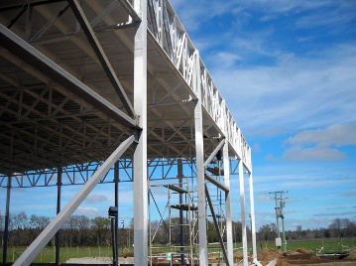
Large-scale infrastructure and construction project executed by PROTOCEM, including civil works, urban development, industrial facilities, hydraulic systems, paving, electrical installations and specialized construction services.
PROJECT 73
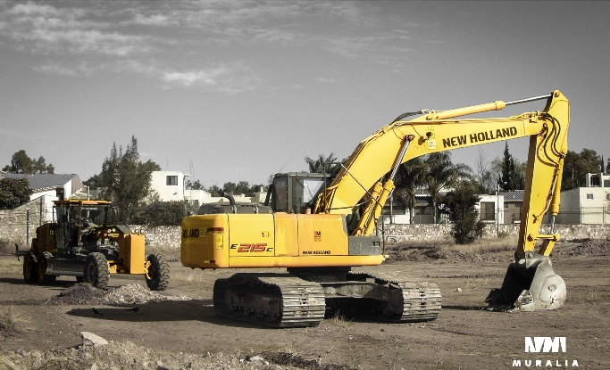
Large-scale infrastructure and construction project executed by PROTOCEM, including civil works, urban development, industrial facilities, hydraulic systems, paving, electrical installations and specialized construction services.
PROJECT 74
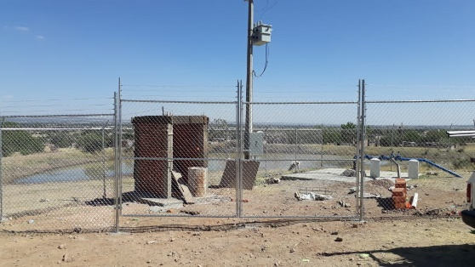
Large-scale infrastructure and construction project executed by PROTOCEM, including civil works, urban development, industrial facilities, hydraulic systems, paving, electrical installations and specialized construction services.
PROJECT 75
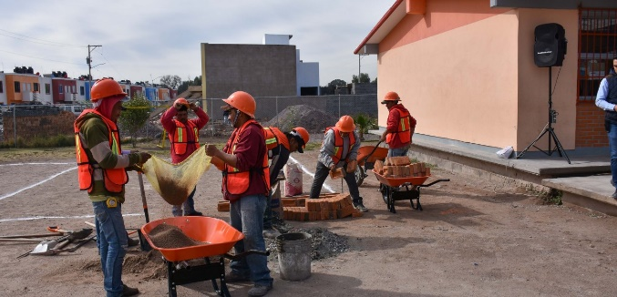
Large-scale infrastructure and construction project executed by PROTOCEM, including civil works, urban development, industrial facilities, hydraulic systems, paving, electrical installations and specialized construction services.
PROJECT 76
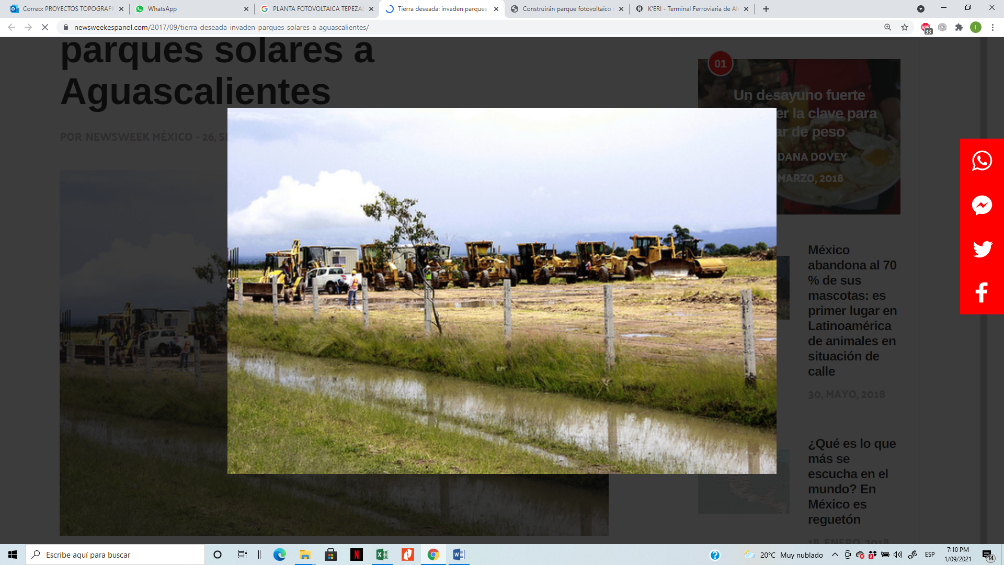
Large-scale infrastructure and construction project executed by PROTOCEM, including civil works, urban development, industrial facilities, hydraulic systems, paving, electrical installations and specialized construction services.
PROJECT 77
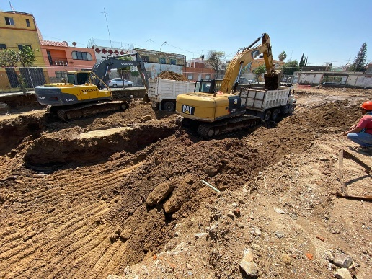
Large-scale infrastructure and construction project executed by PROTOCEM, including civil works, urban development, industrial facilities, hydraulic systems, paving, electrical installations and specialized construction services.
PROJECT 78

Large-scale infrastructure and construction project executed by PROTOCEM, including civil works, urban development, industrial facilities, hydraulic systems, paving, electrical installations and specialized construction services.
PROJECT 79
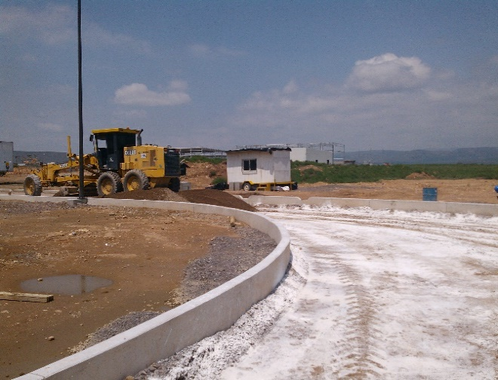
Large-scale infrastructure and construction project executed by PROTOCEM, including civil works, urban development, industrial facilities, hydraulic systems, paving, electrical installations and specialized construction services.
PROJECT 80
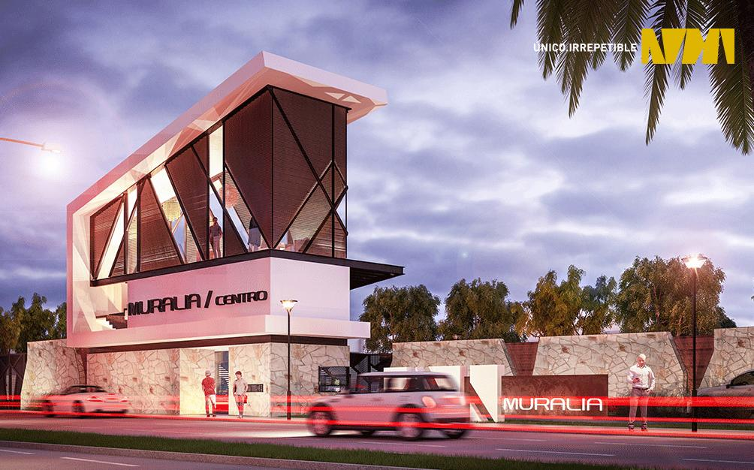
Large-scale infrastructure and construction project executed by PROTOCEM, including civil works, urban development, industrial facilities, hydraulic systems, paving, electrical installations and specialized construction services.
PROJECT 81
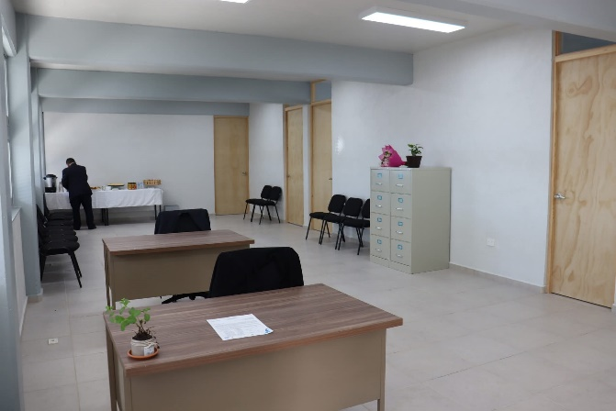
Large-scale infrastructure and construction project executed by PROTOCEM, including civil works, urban development, industrial facilities, hydraulic systems, paving, electrical installations and specialized construction services.
PROJECT 82

Large-scale infrastructure and construction project executed by PROTOCEM, including civil works, urban development, industrial facilities, hydraulic systems, paving, electrical installations and specialized construction services.
PROJECT 83

Large-scale infrastructure and construction project executed by PROTOCEM, including civil works, urban development, industrial facilities, hydraulic systems, paving, electrical installations and specialized construction services.
PROJECT 84
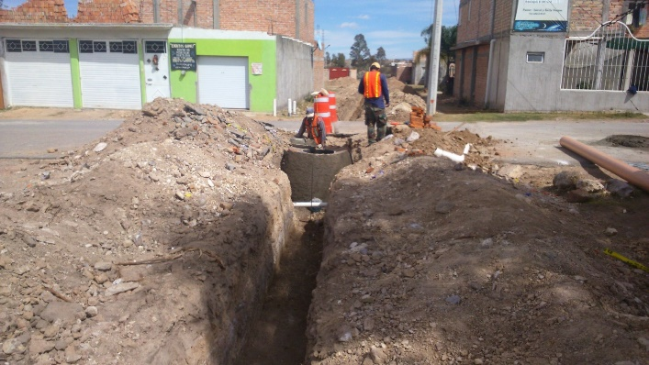
Large-scale infrastructure and construction project executed by PROTOCEM, including civil works, urban development, industrial facilities, hydraulic systems, paving, electrical installations and specialized construction services.
PROJECT 85
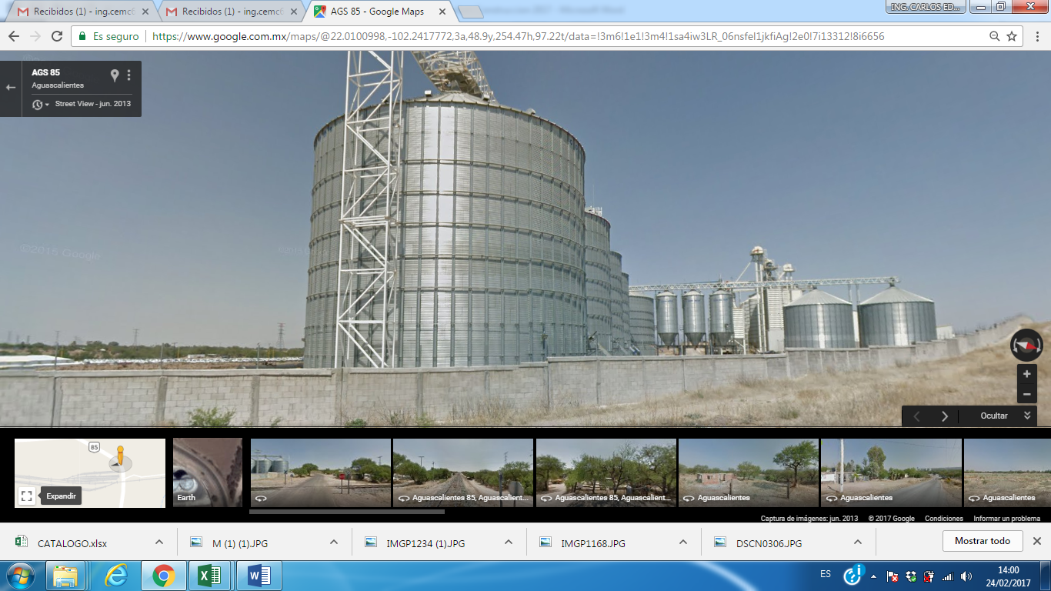
Large-scale infrastructure and construction project executed by PROTOCEM, including civil works, urban development, industrial facilities, hydraulic systems, paving, electrical installations and specialized construction services.
PROJECT 86
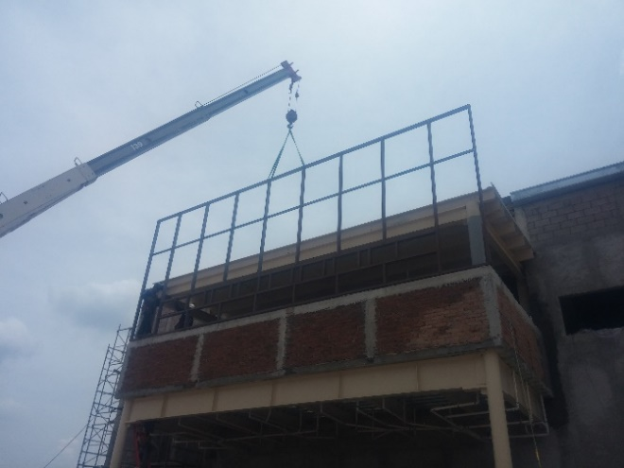
Large-scale infrastructure and construction project executed by PROTOCEM, including civil works, urban development, industrial facilities, hydraulic systems, paving, electrical installations and specialized construction services.
PROJECT 87
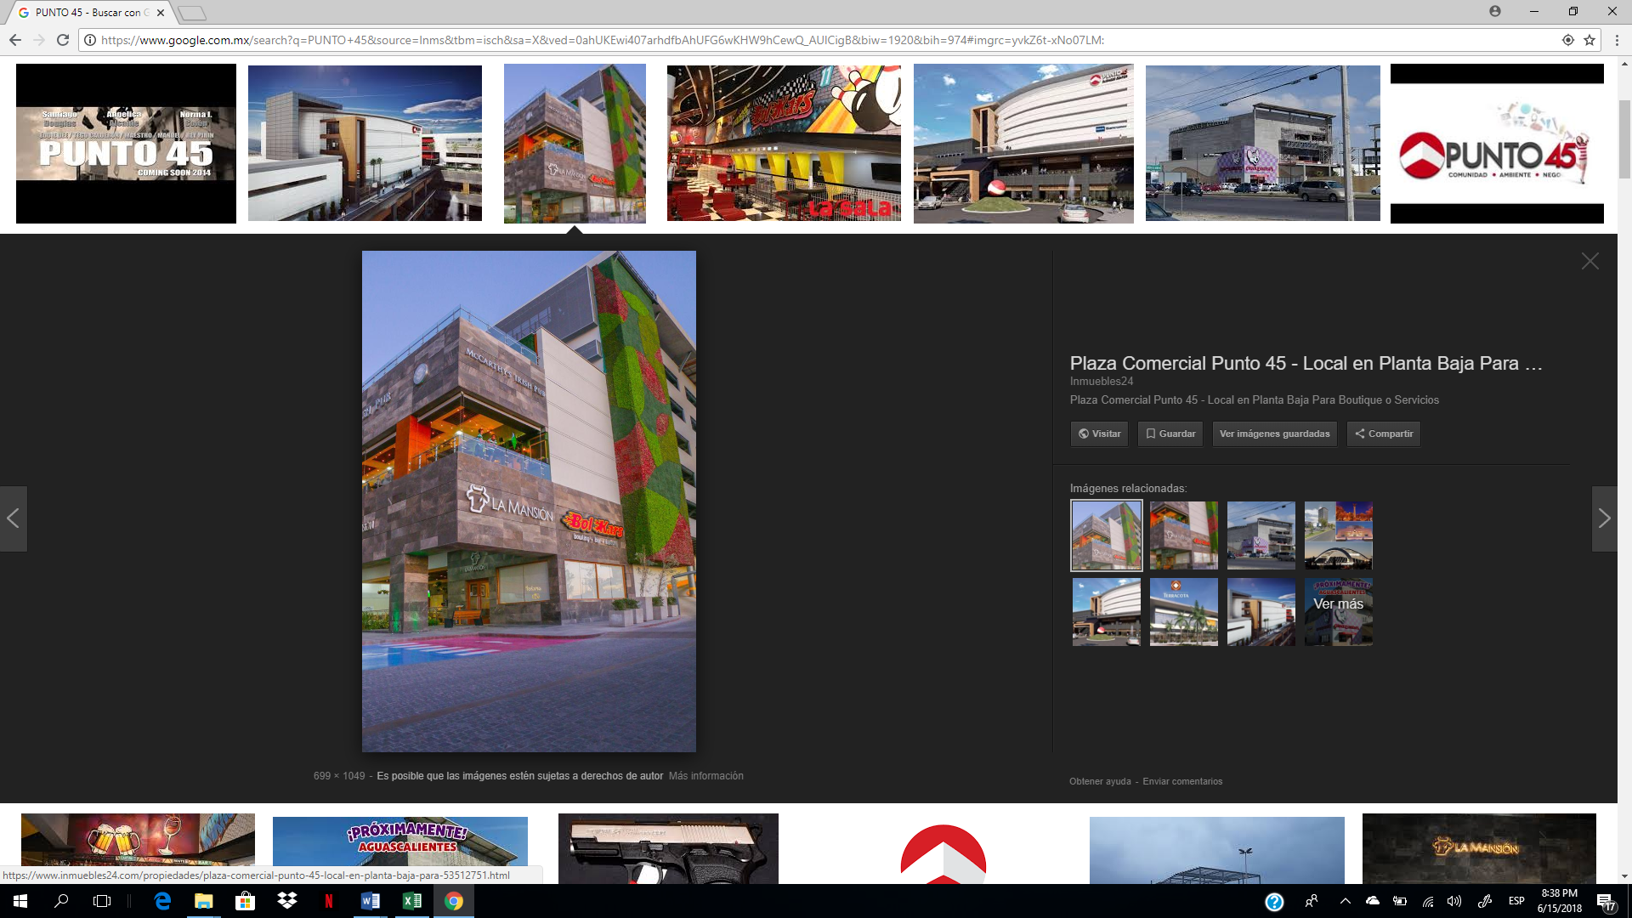
Large-scale infrastructure and construction project executed by PROTOCEM, including civil works, urban development, industrial facilities, hydraulic systems, paving, electrical installations and specialized construction services.
PROJECT 88
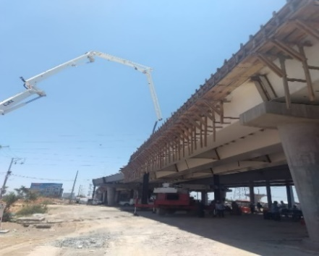
Large-scale infrastructure and construction project executed by PROTOCEM, including civil works, urban development, industrial facilities, hydraulic systems, paving, electrical installations and specialized construction services.
PROJECT 89
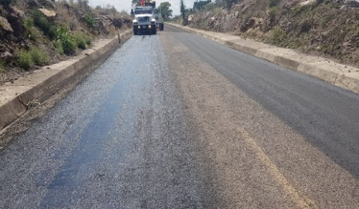
Large-scale infrastructure and construction project executed by PROTOCEM, including civil works, urban development, industrial facilities, hydraulic systems, paving, electrical installations and specialized construction services.
PROJECT 90
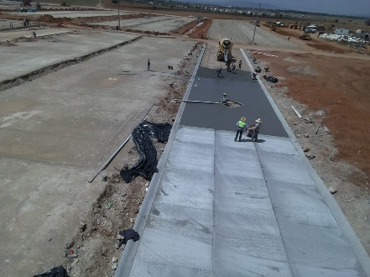
Large-scale infrastructure and construction project executed by PROTOCEM, including civil works, urban development, industrial facilities, hydraulic systems, paving, electrical installations and specialized construction services.
PROJECT 91
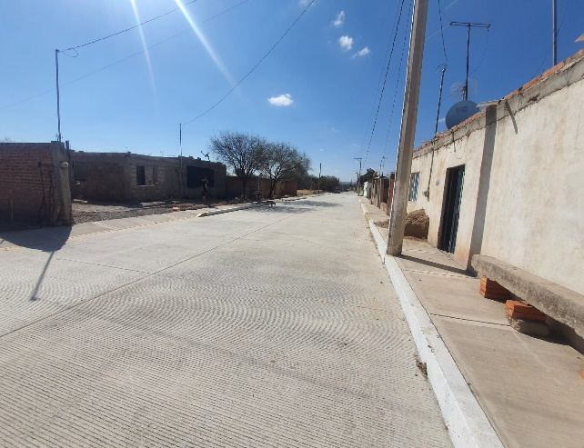
Large-scale infrastructure and construction project executed by PROTOCEM, including civil works, urban development, industrial facilities, hydraulic systems, paving, electrical installations and specialized construction services.
PROJECT 92
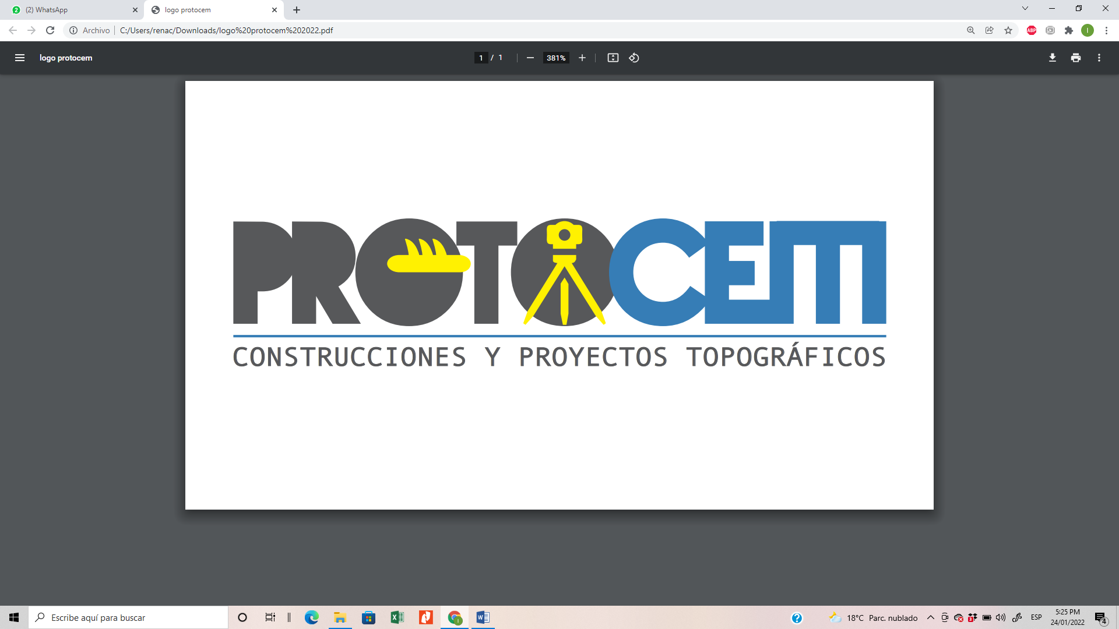
Large-scale infrastructure and construction project executed by PROTOCEM, including civil works, urban development, industrial facilities, hydraulic systems, paving, electrical installations and specialized construction services.
PROJECT 93
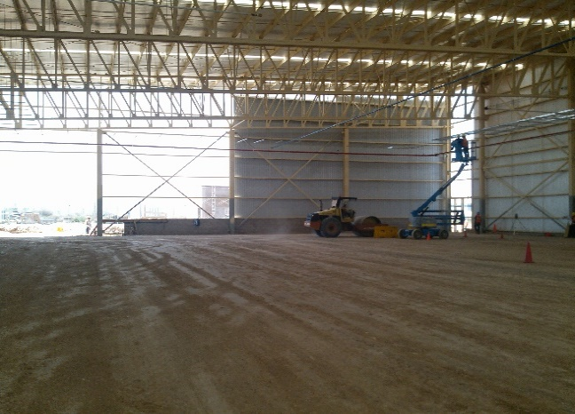
Large-scale infrastructure and construction project executed by PROTOCEM, including civil works, urban development, industrial facilities, hydraulic systems, paving, electrical installations and specialized construction services.
PROJECT 94
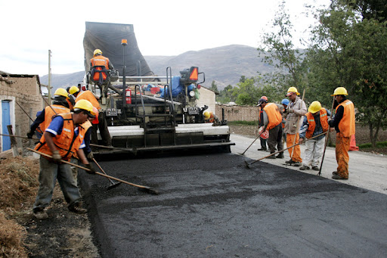
Large-scale infrastructure and construction project executed by PROTOCEM, including civil works, urban development, industrial facilities, hydraulic systems, paving, electrical installations and specialized construction services.
PROJECT 95
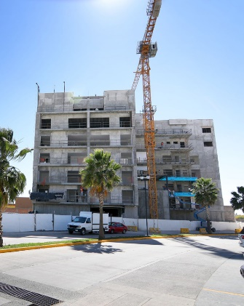
Large-scale infrastructure and construction project executed by PROTOCEM, including civil works, urban development, industrial facilities, hydraulic systems, paving, electrical installations and specialized construction services.
PROJECT 96
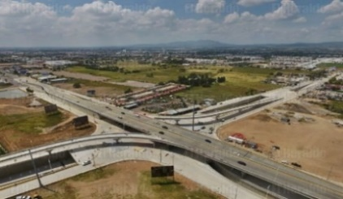
Large-scale infrastructure and construction project executed by PROTOCEM, including civil works, urban development, industrial facilities, hydraulic systems, paving, electrical installations and specialized construction services.
PROJECT 97
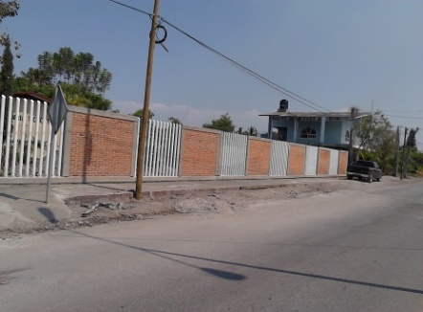
Large-scale infrastructure and construction project executed by PROTOCEM, including civil works, urban development, industrial facilities, hydraulic systems, paving, electrical installations and specialized construction services.
PROJECT 98
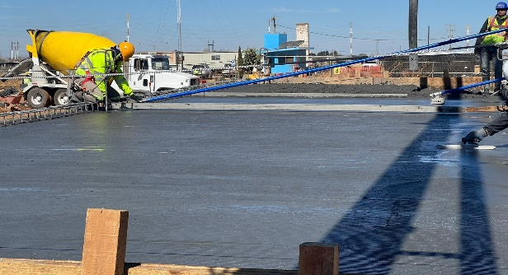
Large-scale infrastructure and construction project executed by PROTOCEM, including civil works, urban development, industrial facilities, hydraulic systems, paving, electrical installations and specialized construction services.
PROJECT 99

Large-scale infrastructure and construction project executed by PROTOCEM, including civil works, urban development, industrial facilities, hydraulic systems, paving, electrical installations and specialized construction services.
PROJECT 100
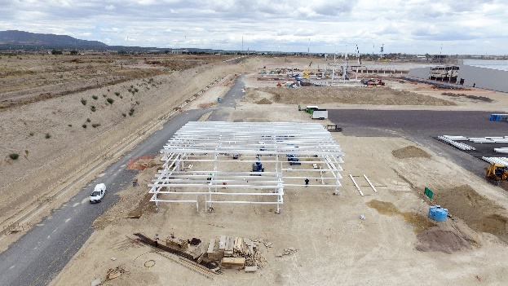
Large-scale infrastructure and construction project executed by PROTOCEM, including civil works, urban development, industrial facilities, hydraulic systems, paving, electrical installations and specialized construction services.
PROJECT 101
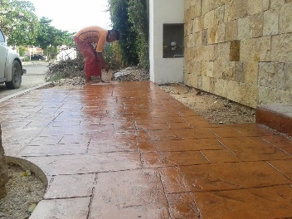
Large-scale infrastructure and construction project executed by PROTOCEM, including civil works, urban development, industrial facilities, hydraulic systems, paving, electrical installations and specialized construction services.
PROJECT 102
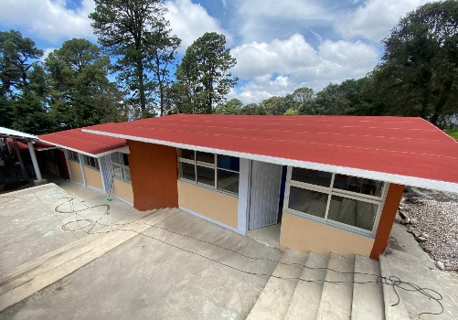
Large-scale infrastructure and construction project executed by PROTOCEM, including civil works, urban development, industrial facilities, hydraulic systems, paving, electrical installations and specialized construction services.
PROJECT 103
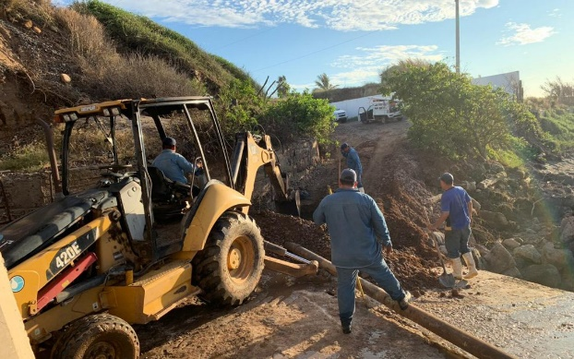
Large-scale infrastructure and construction project executed by PROTOCEM, including civil works, urban development, industrial facilities, hydraulic systems, paving, electrical installations and specialized construction services.
PROJECT 104

Large-scale infrastructure and construction project executed by PROTOCEM, including civil works, urban development, industrial facilities, hydraulic systems, paving, electrical installations and specialized construction services.
PROJECT 105

Large-scale infrastructure and construction project executed by PROTOCEM, including civil works, urban development, industrial facilities, hydraulic systems, paving, electrical installations and specialized construction services.
PROJECT 106
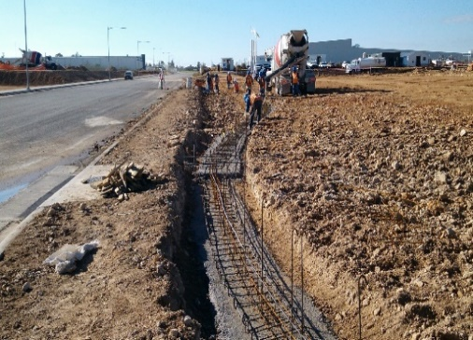
Large-scale infrastructure and construction project executed by PROTOCEM, including civil works, urban development, industrial facilities, hydraulic systems, paving, electrical installations and specialized construction services.
PROJECT 107
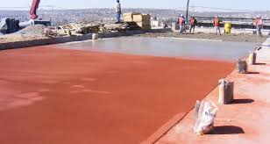
Large-scale infrastructure and construction project executed by PROTOCEM, including civil works, urban development, industrial facilities, hydraulic systems, paving, electrical installations and specialized construction services.
PROJECT 108
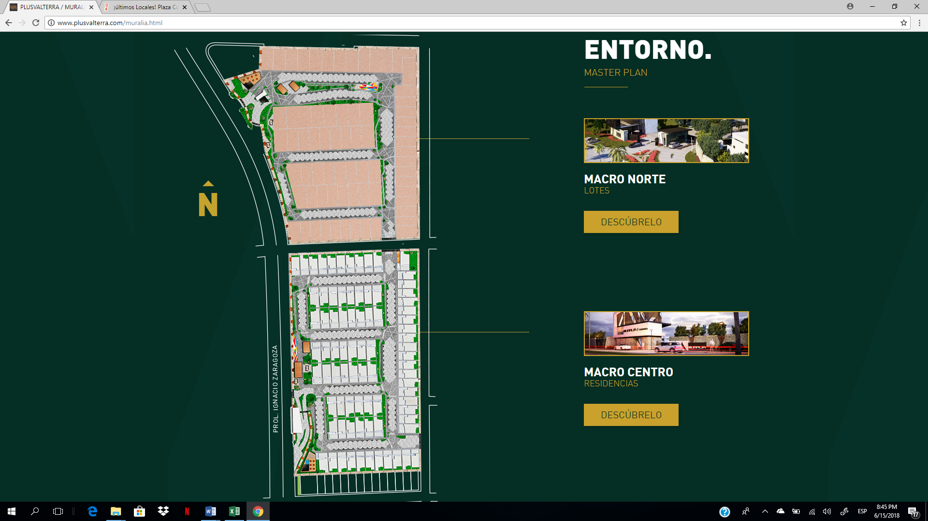
Large-scale infrastructure and construction project executed by PROTOCEM, including civil works, urban development, industrial facilities, hydraulic systems, paving, electrical installations and specialized construction services.
PROJECT 109
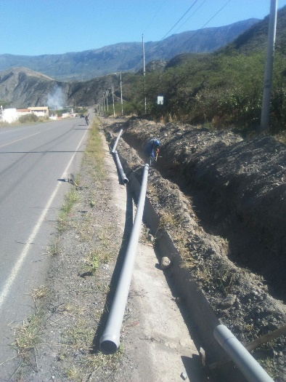
Large-scale infrastructure and construction project executed by PROTOCEM, including civil works, urban development, industrial facilities, hydraulic systems, paving, electrical installations and specialized construction services.
PROJECT 110
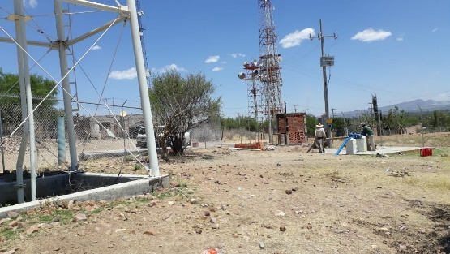
Large-scale infrastructure and construction project executed by PROTOCEM, including civil works, urban development, industrial facilities, hydraulic systems, paving, electrical installations and specialized construction services.
PROJECT 111
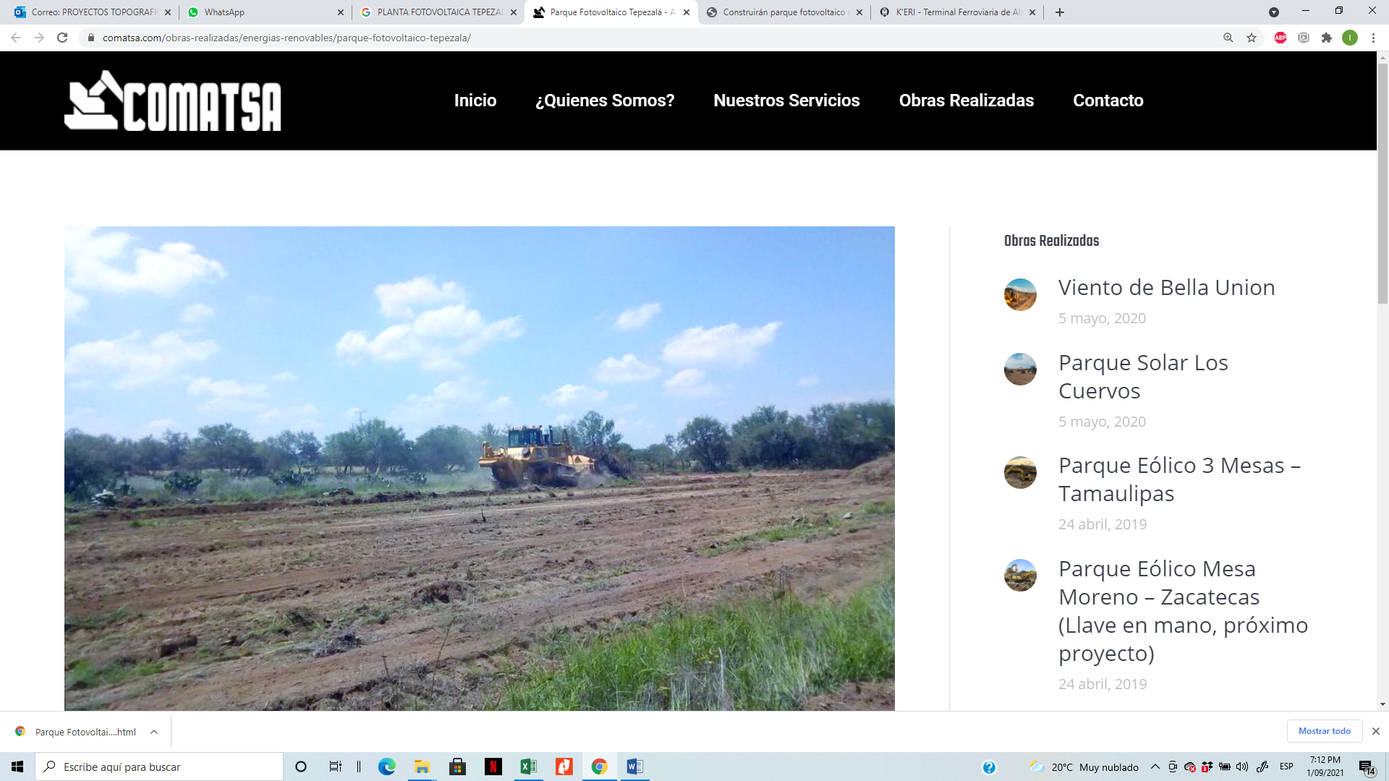
Large-scale infrastructure and construction project executed by PROTOCEM, including civil works, urban development, industrial facilities, hydraulic systems, paving, electrical installations and specialized construction services.
PROJECT 112
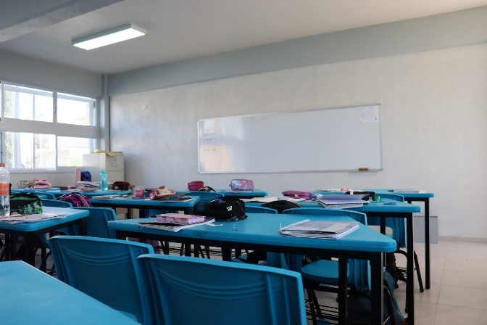
Large-scale infrastructure and construction project executed by PROTOCEM, including civil works, urban development, industrial facilities, hydraulic systems, paving, electrical installations and specialized construction services.
PROJECT 113
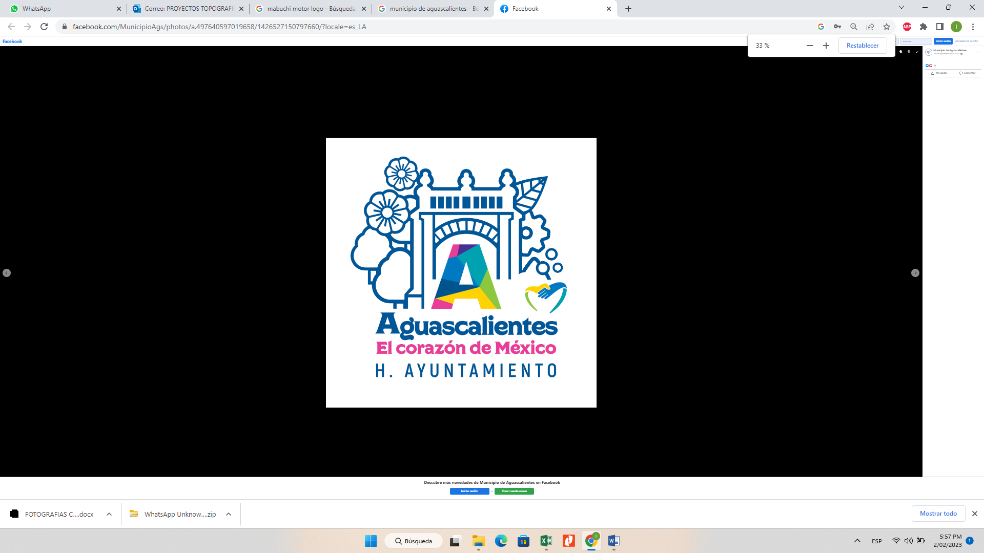
Large-scale infrastructure and construction project executed by PROTOCEM, including civil works, urban development, industrial facilities, hydraulic systems, paving, electrical installations and specialized construction services.
PROJECT 114
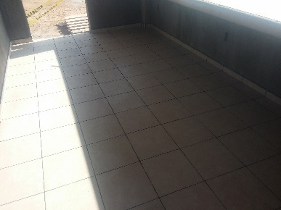
Large-scale infrastructure and construction project executed by PROTOCEM, including civil works, urban development, industrial facilities, hydraulic systems, paving, electrical installations and specialized construction services.
PROJECT 115
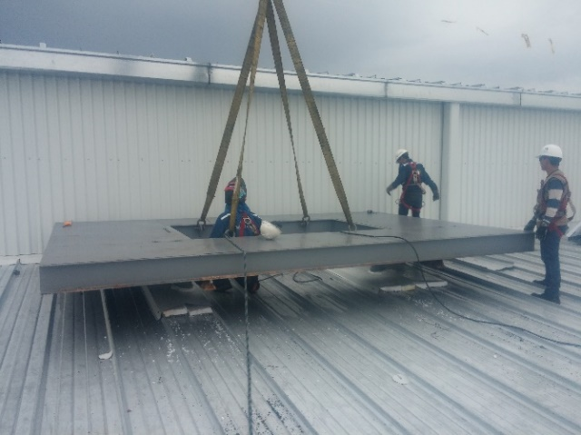
Large-scale infrastructure and construction project executed by PROTOCEM, including civil works, urban development, industrial facilities, hydraulic systems, paving, electrical installations and specialized construction services.
PROJECT 116
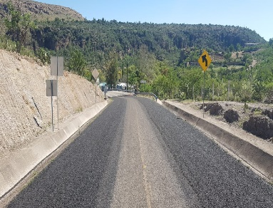
Large-scale infrastructure and construction project executed by PROTOCEM, including civil works, urban development, industrial facilities, hydraulic systems, paving, electrical installations and specialized construction services.
PROJECT 117
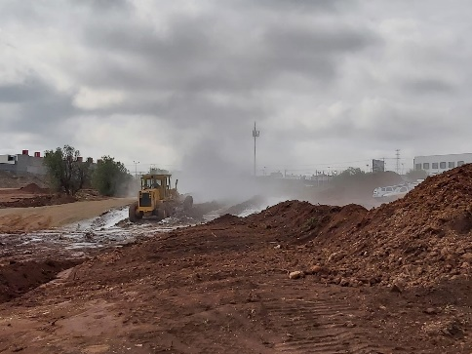
Large-scale infrastructure and construction project executed by PROTOCEM, including civil works, urban development, industrial facilities, hydraulic systems, paving, electrical installations and specialized construction services.
PROJECT 118

Large-scale infrastructure and construction project executed by PROTOCEM, including civil works, urban development, industrial facilities, hydraulic systems, paving, electrical installations and specialized construction services.
PROJECT 119
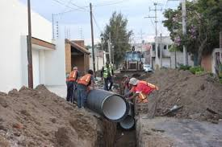
Large-scale infrastructure and construction project executed by PROTOCEM, including civil works, urban development, industrial facilities, hydraulic systems, paving, electrical installations and specialized construction services.
PROJECT 120
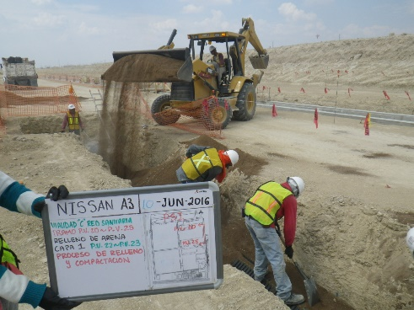
Large-scale infrastructure and construction project executed by PROTOCEM, including civil works, urban development, industrial facilities, hydraulic systems, paving, electrical installations and specialized construction services.
PROJECT 121
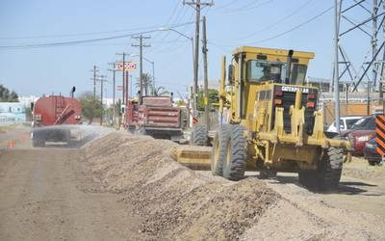
Large-scale infrastructure and construction project executed by PROTOCEM, including civil works, urban development, industrial facilities, hydraulic systems, paving, electrical installations and specialized construction services.
PROJECT 122
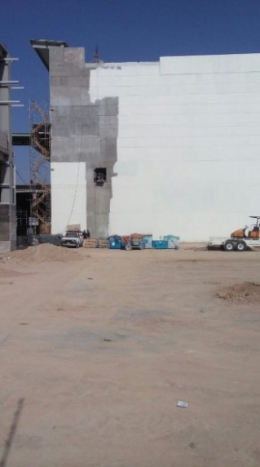
Large-scale infrastructure and construction project executed by PROTOCEM, including civil works, urban development, industrial facilities, hydraulic systems, paving, electrical installations and specialized construction services.
PROJECT 123
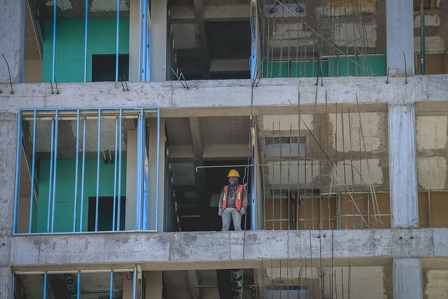
Large-scale infrastructure and construction project executed by PROTOCEM, including civil works, urban development, industrial facilities, hydraulic systems, paving, electrical installations and specialized construction services.
PROJECT 124
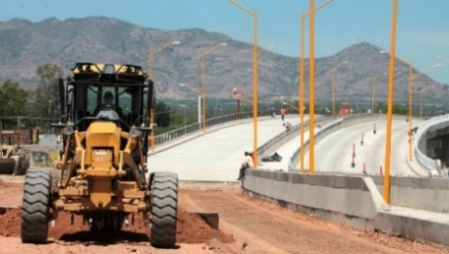
Large-scale infrastructure and construction project executed by PROTOCEM, including civil works, urban development, industrial facilities, hydraulic systems, paving, electrical installations and specialized construction services.
PROJECT 125
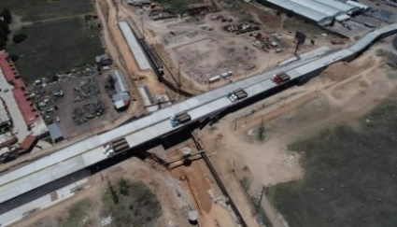
Large-scale infrastructure and construction project executed by PROTOCEM, including civil works, urban development, industrial facilities, hydraulic systems, paving, electrical installations and specialized construction services.
PROJECT 126
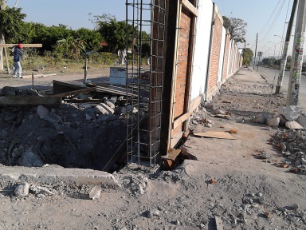
Large-scale infrastructure and construction project executed by PROTOCEM, including civil works, urban development, industrial facilities, hydraulic systems, paving, electrical installations and specialized construction services.
PROJECT 127
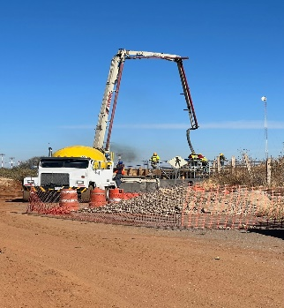
Large-scale infrastructure and construction project executed by PROTOCEM, including civil works, urban development, industrial facilities, hydraulic systems, paving, electrical installations and specialized construction services.
PROJECT 128
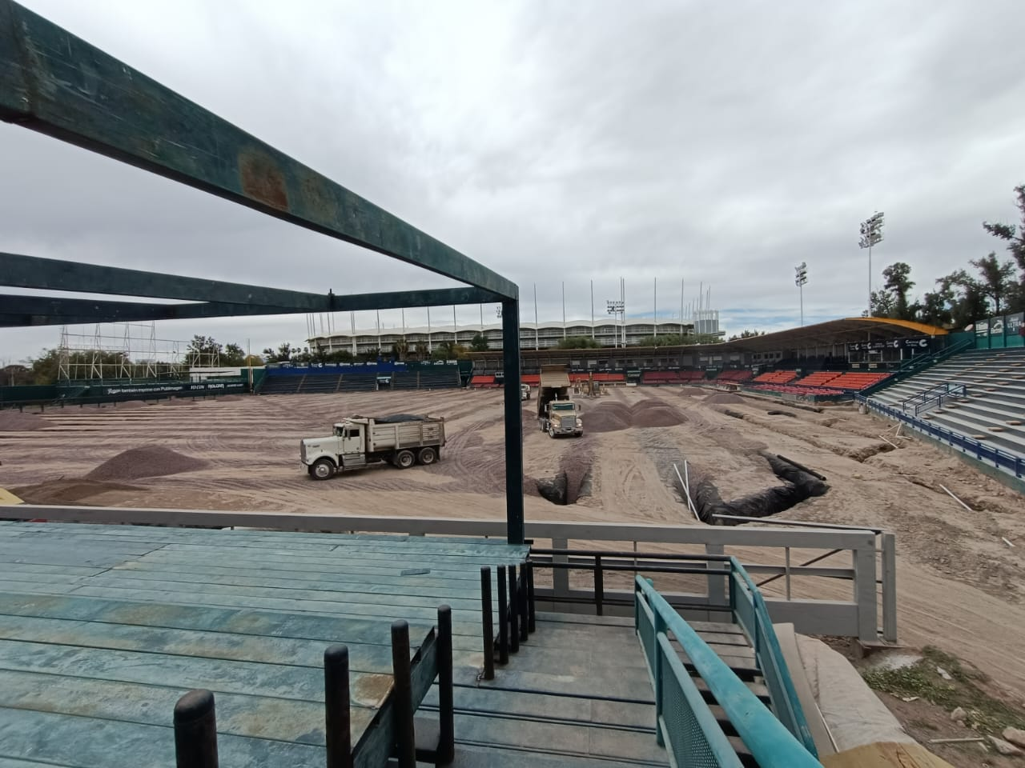
Large-scale infrastructure and construction project executed by PROTOCEM, including civil works, urban development, industrial facilities, hydraulic systems, paving, electrical installations and specialized construction services.
PROJECT 129
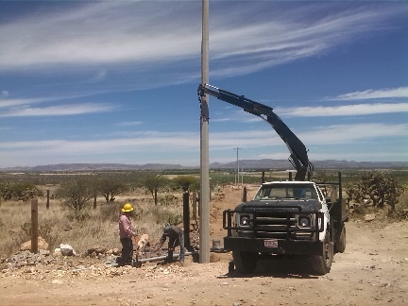
Large-scale infrastructure and construction project executed by PROTOCEM, including civil works, urban development, industrial facilities, hydraulic systems, paving, electrical installations and specialized construction services.
PROJECT 130
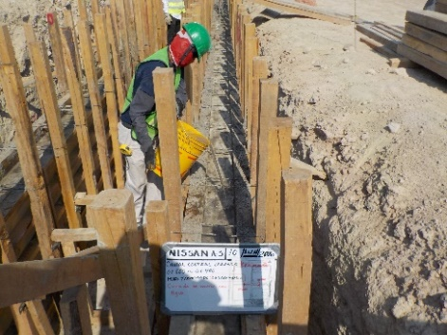
Large-scale infrastructure and construction project executed by PROTOCEM, including civil works, urban development, industrial facilities, hydraulic systems, paving, electrical installations and specialized construction services.
PROJECT 131
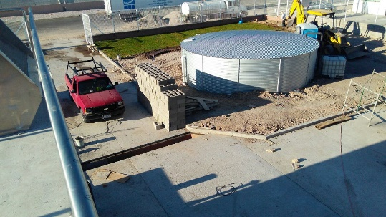
Large-scale infrastructure and construction project executed by PROTOCEM, including civil works, urban development, industrial facilities, hydraulic systems, paving, electrical installations and specialized construction services.
PROJECT 132
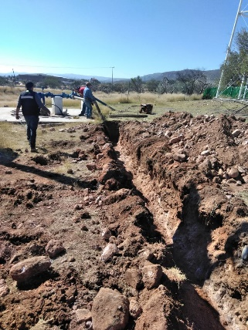
Large-scale infrastructure and construction project executed by PROTOCEM, including civil works, urban development, industrial facilities, hydraulic systems, paving, electrical installations and specialized construction services.
PROJECT 133
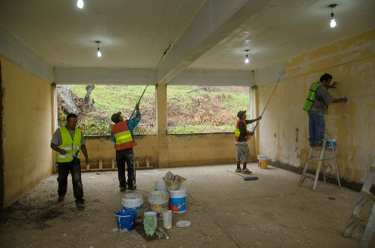
Large-scale infrastructure and construction project executed by PROTOCEM, including civil works, urban development, industrial facilities, hydraulic systems, paving, electrical installations and specialized construction services.
PROJECT 134
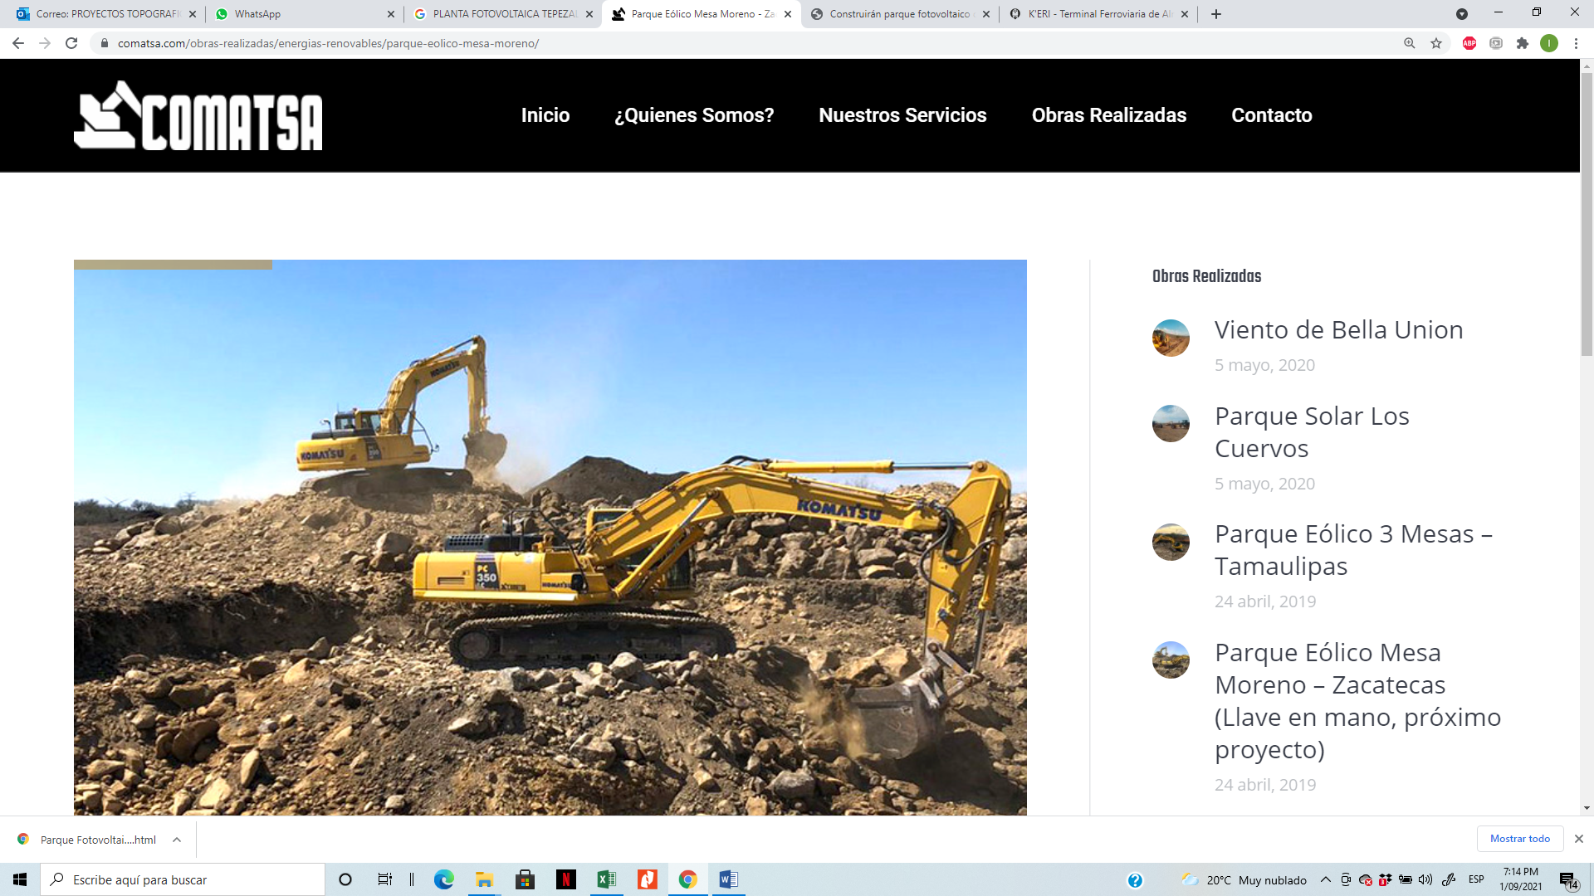
Large-scale infrastructure and construction project executed by PROTOCEM, including civil works, urban development, industrial facilities, hydraulic systems, paving, electrical installations and specialized construction services.
PROJECT 135
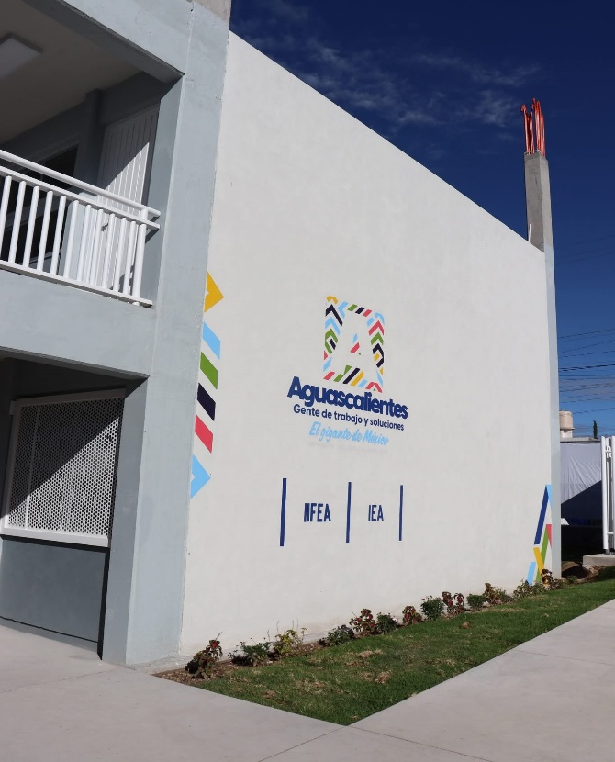
Large-scale infrastructure and construction project executed by PROTOCEM, including civil works, urban development, industrial facilities, hydraulic systems, paving, electrical installations and specialized construction services.
PROJECT 136

Large-scale infrastructure and construction project executed by PROTOCEM, including civil works, urban development, industrial facilities, hydraulic systems, paving, electrical installations and specialized construction services.
PROJECT 137
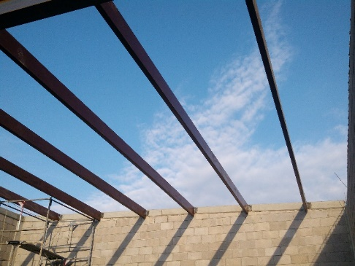
Large-scale infrastructure and construction project executed by PROTOCEM, including civil works, urban development, industrial facilities, hydraulic systems, paving, electrical installations and specialized construction services.
PROJECT 138
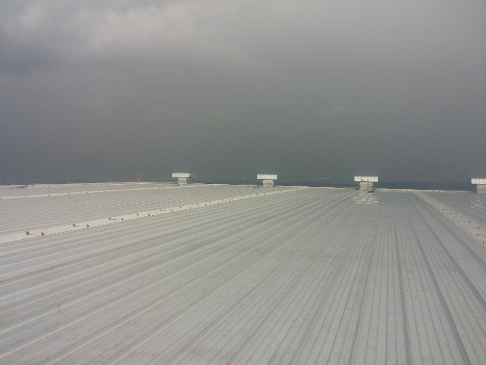
Large-scale infrastructure and construction project executed by PROTOCEM, including civil works, urban development, industrial facilities, hydraulic systems, paving, electrical installations and specialized construction services.
PROJECT 139
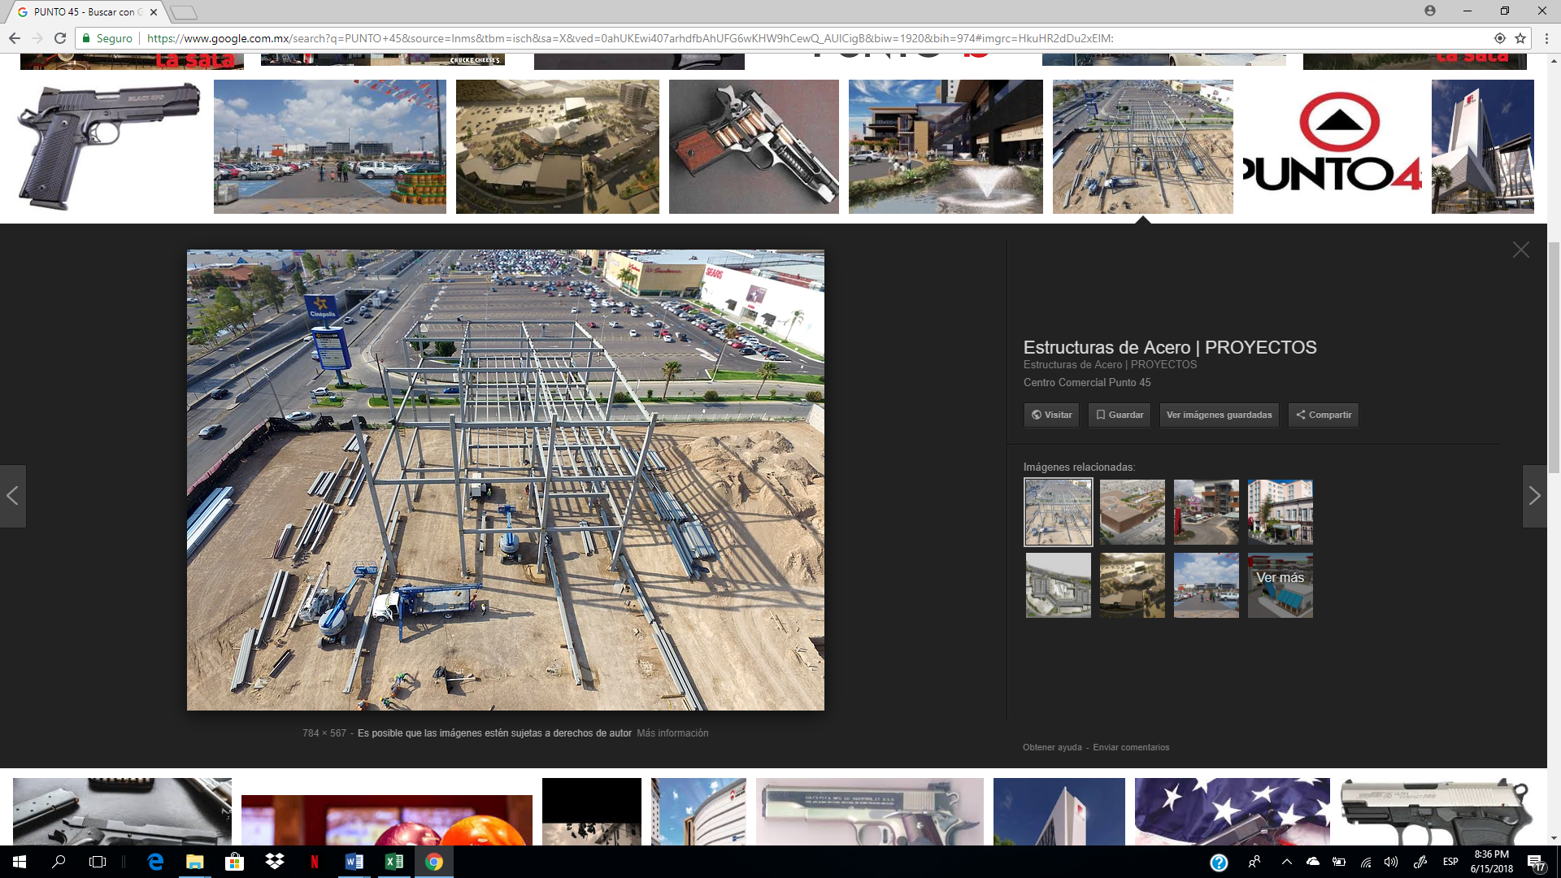
Large-scale infrastructure and construction project executed by PROTOCEM, including civil works, urban development, industrial facilities, hydraulic systems, paving, electrical installations and specialized construction services.
PROJECT 140
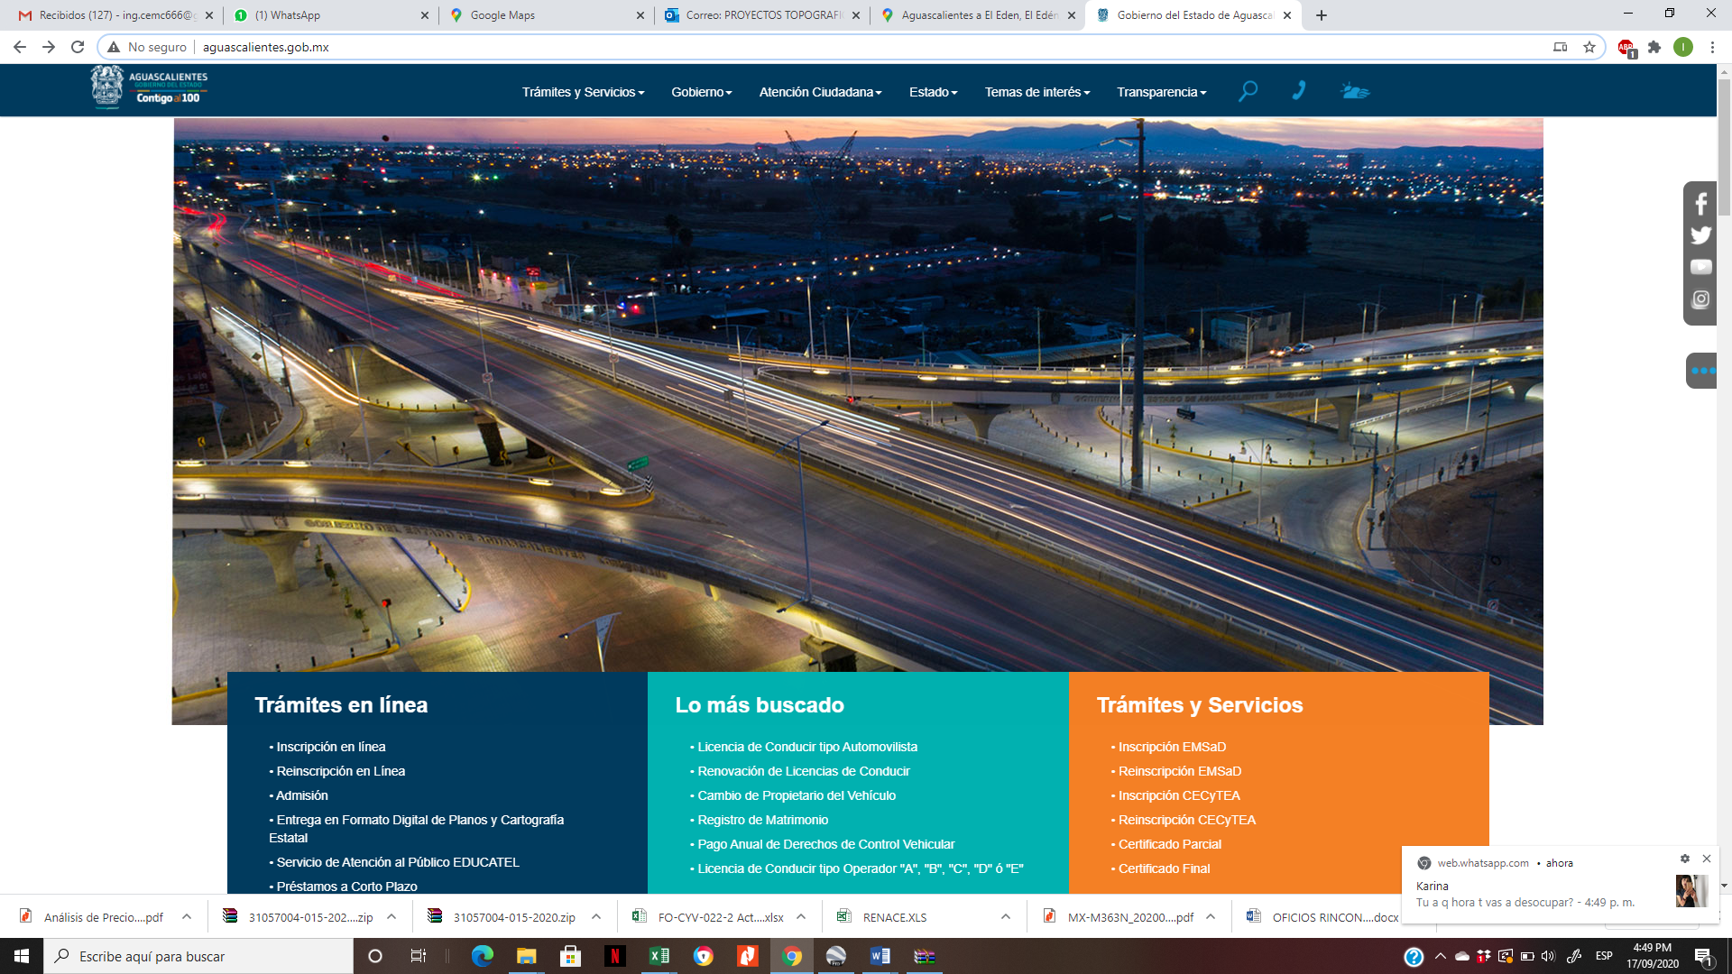
Large-scale infrastructure and construction project executed by PROTOCEM, including civil works, urban development, industrial facilities, hydraulic systems, paving, electrical installations and specialized construction services.
PROJECT 141
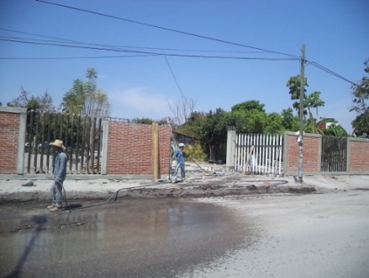
Large-scale infrastructure and construction project executed by PROTOCEM, including civil works, urban development, industrial facilities, hydraulic systems, paving, electrical installations and specialized construction services.
PROJECT 142
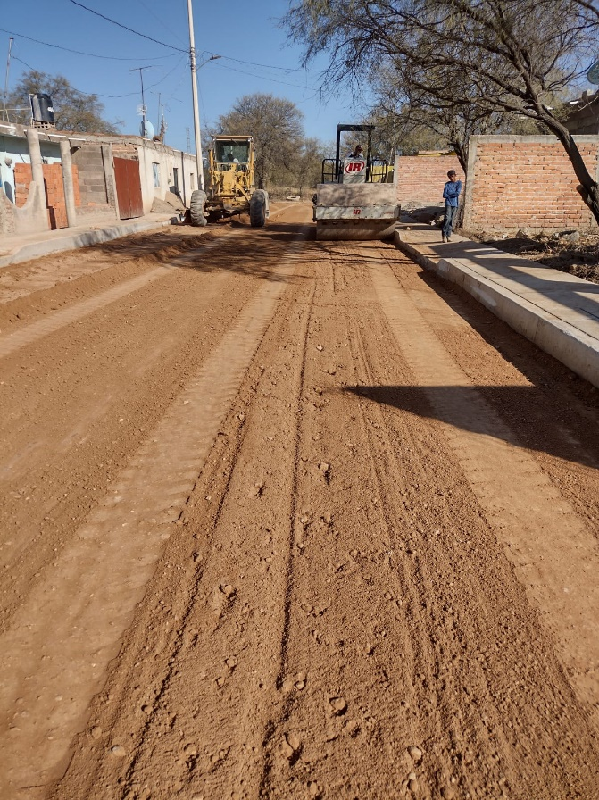
Large-scale infrastructure and construction project executed by PROTOCEM, including civil works, urban development, industrial facilities, hydraulic systems, paving, electrical installations and specialized construction services.
PROJECT 143
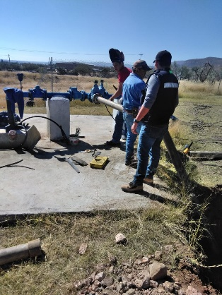
Large-scale infrastructure and construction project executed by PROTOCEM, including civil works, urban development, industrial facilities, hydraulic systems, paving, electrical installations and specialized construction services.
PROJECT 144
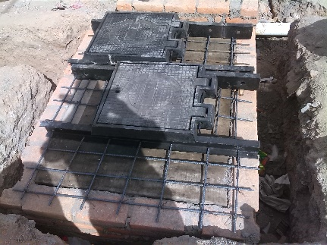
Large-scale infrastructure and construction project executed by PROTOCEM, including civil works, urban development, industrial facilities, hydraulic systems, paving, electrical installations and specialized construction services.
PROJECT 145
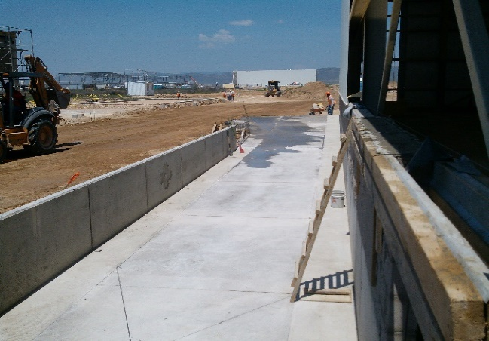
Large-scale infrastructure and construction project executed by PROTOCEM, including civil works, urban development, industrial facilities, hydraulic systems, paving, electrical installations and specialized construction services.
PROJECT 146
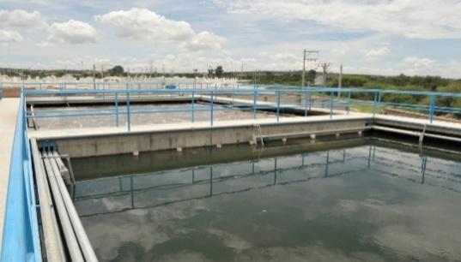
Large-scale infrastructure and construction project executed by PROTOCEM, including civil works, urban development, industrial facilities, hydraulic systems, paving, electrical installations and specialized construction services.
PROJECT 147
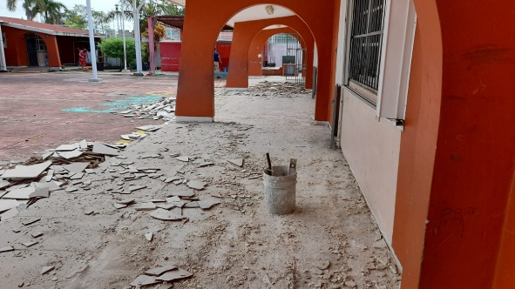
Large-scale infrastructure and construction project executed by PROTOCEM, including civil works, urban development, industrial facilities, hydraulic systems, paving, electrical installations and specialized construction services.
PROJECT 148
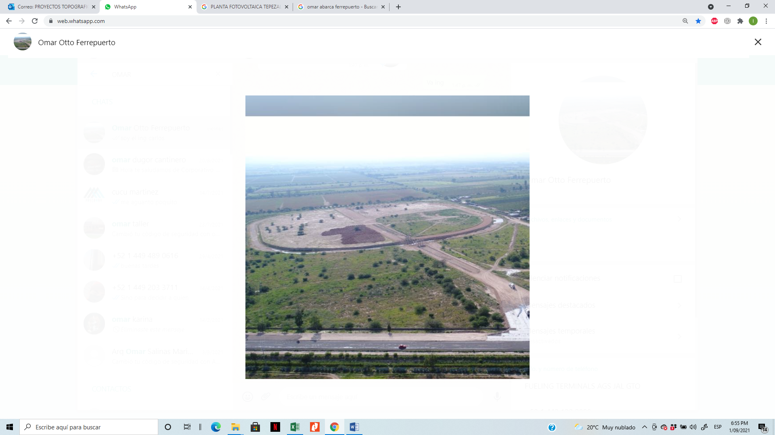
Large-scale infrastructure and construction project executed by PROTOCEM, including civil works, urban development, industrial facilities, hydraulic systems, paving, electrical installations and specialized construction services.
PROJECT 149
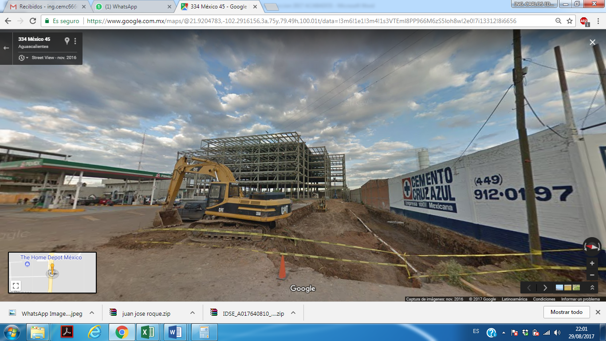
Large-scale infrastructure and construction project executed by PROTOCEM, including civil works, urban development, industrial facilities, hydraulic systems, paving, electrical installations and specialized construction services.
PROJECT 150
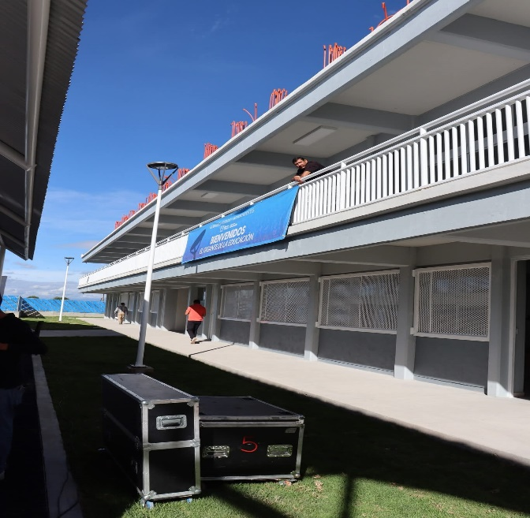
Large-scale infrastructure and construction project executed by PROTOCEM, including civil works, urban development, industrial facilities, hydraulic systems, paving, electrical installations and specialized construction services.

CORPORATE INFORMATION
Commercial Name: PROTOCEM
Legal Representative: I.C. Carlos Eduardo Macías Cháirez
Professional License: 6151593
Address: J. Encarnación Payén #515, Aguascalientes, Mexico
Email: protocem@hotmail.com
Phone: +52 449-137-29-71

